Home Learning Plans
Beech Class
Week Beginning: Monday 22nd June
Reading:
- This Friday, at 9:30am, we will use Google Meet to continue our class story. We will be reading Chapters 3 and 4 of Matilda. We will send out a parent-pay message with a link, which you can use to join our meeting. (Alternatively, you can watch a recorded version of Chapters 3 and 4 on the school you tube channel.)

- Complete the reading comprehension questions for Chapters 3 and 4 of Matilda.

- Sign up for this year’s Summer Reading Challenge. It started on Friday 5 June and runs throughout the summer holidays, finishing at the end of September. It is aimed at children aged 4 – 11 and is completely free! The challenge features games, quizzes and downloadable activities to incentivise and encourage children and their families to take part in reading related activities at home. Children can choose their own reading goals, create book reviews, play games and collect virtual rewards. Parents and guardians can register their children online at www.sillysquad.org.uk
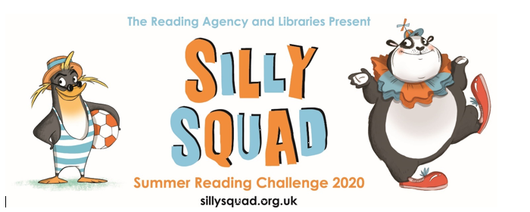

- Visit the Oxford Owl website. https://www.oxfordowl.co.uk/ Click on the My Class Login section

Use the following details to log in to the newly created beech class section.
Username: beechclass101
Password: pupil
Click on the ‘My Bookshelf’ section and select reading books that are right for you. Use the ‘Age Groups’ section to help narrow down the search.

- When completing guided or supported reading of an age appropriate text, focus on analytical questioning. Use the analytical section of this questioning tool to generate questions that challenge your child to analyse what has happened in the story.

- For example:
-Why did they do that?
-How can you tell that…?

Spelling:
- Log on to Purple Mash and complete the spelling ‘2Dos’ which have been selected for you.

Writing: For the last few weeks of the term, we are going to focus on our new class book, Matilda.
- Reread or listen to Chapters 1 and 2 of Matilda. Collect words or phrases that Roald Dahl uses to describe Matilda. Use these words and phrases to create a ‘Matilda Mind-Map’ using the sheet provided. You can add on any other extra words and phrases that you would use to describe Matilda.
- Reread or listen to the Chapters 1 and 2 of Matilda. Collect words or phrases that Roald Dahl uses to describe Mr Wormwood. Use these words and phrases to create a ‘Mr Wormwood Mind-Map’ using the sheet provided. You can add on any other extra words and phrases that you would use to describe Mr Wormwood.
- Read Mr Ms modelled description of Matilda and watch the Matilda description learning video:
- Use the colour coded ‘Matilda Character Description Help Sheet’ to create a character description of Matilda.
- Read Mr Ms modelled description of Mr Wormwood. Use the colour coded ‘Mr Wormwood Character Description Help Sheet’ to create a character description of Mr Wormwood.

Maths:
This week we are going to turn our attention to addition and subtraction. In particular, we are going to focus on how counting forwards and backwards in jumps of 1 and/or 10s can be used to add and subtract accurately.
- Watch the ‘Adding and Subtracting 1s’ learning video.
- Use your counting forwards and backwards in 1s skills to complete the ‘Adding and Subtracting 1 Number Tracks’ activity.
- Play the counting forwards and backwards in 1s game as modelled in the learning video. Use this game to help you to practise counting forwards and backwards in 1s. Pay particular attention to crossing 10s barriers.
IMPORTANT: This is the key skill which everything else we do in the week will be based upon. Please make sure you master this skill before moving on. If you are finding it difficult, try using a 0-100 number-line to support you.
- Watch the ‘Adding and Subtracting 10s’ learning video.
- Use your counting forwards and backwards in 10s skills to complete the ‘Adding and Subtracting 10s Number Tracks’ activity.
- Play the counting forwards and backwards in 10s game as modelled in the learning video. Use this game to help you to practise counting forwards and backwards in 10s.
IMPORTANT: This is the key skill which everything else we do in the week will be based upon. Please make sure you master this skill before moving on. If you are finding it difficult, try using a hundred square to support you.
- Watch the ‘Using a Number-line to Add and Subtract’ learning video.
- Use this technique to solve the ‘Adding and Subtracting 10s and 1s Calculations’ activity.
When you feel really confident at using a blank number-line to add and subtract, use this technique to complete these MyMaths activities.
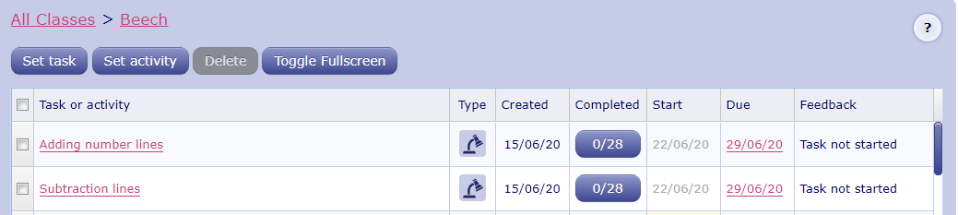

Number Fluency: This week we are going to continue to focus on doubling and halving for the numbers up to 20.
- If you haven’t done so already, watch the doubling and halving learning video.
- Use the ‘doubling and halving cards’ to practise you doubles and halves for the numbers up to 20.
- Cut along the dotted lines on the ‘Doubles and Halves’ activity. Pick out a strip and use the numicon images to help create as many different double and half statements as possible. e.g.
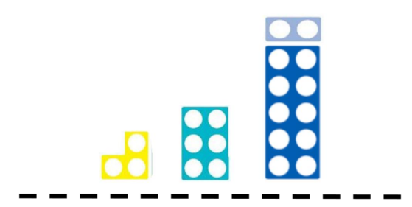
-Double 3 is 6.
-Double 6 is 12.
-Half of 12 is 6.
-Half of 6 is 3.
Repeat this with all of the different strips.
- Test yourself. Can you instantly recall all the doubling facts for the numbers up to 20?
-Double 1?
-Double 2?
-Double 3?
-Double 4?
-Double 5?
-Double 6?
-Double 7?
-Double 8?
-Double 9?
-Double 10?
Keep on practising until you know these facts instantly.

- Test yourself. Can you instantly recall all the halving facts for the numbers up to 20?
-Half 2?
-Half 4?
-Half 6?
-Half 8?
-Half 10?
-Half 12?
-Half 14?
-Half 16?
-Half 18?
-Half 20?
Keep on practising until you know these facts instantly.

Wider Curriculum
- Pick activities of your choice from the wider curriculum matrix.

