Re-read or listen again to Chapters 1 and 2 of Matilda. Collect words and phrases that Roald Dahl uses to describe Mr Wormwood and add them to this mind-map.

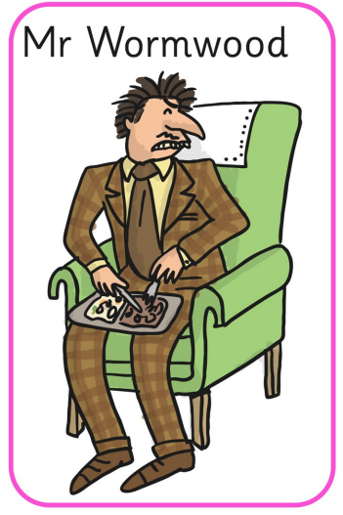

Extension: Add your own words and phrases that you would use to describe Mr Wormwood.

