Watch the learning video and use Mr M’s modelled example to create your own Mr Wormwood character description.
In a quiet village, | On a mundane road, | In an ordinary street
Not far from here, | Just around the corner, | Down the road,

T.V dinners | video games | gameshows
mindlessness | television | boredom
rudeness | arguments | dishonesty

rude | dim-witted | dishonest
untrustworthy | unkind | thoughtless
disreputable | mean | awful
unpleasant | boastful | vein

He was the sort of man who…

He was as ______________ as a _____________________
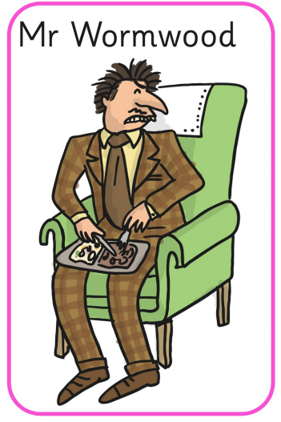
Covering his body…
Around his neck
On his face…
On his feet…

What a _______________ man he was!

