Use your understanding from the ‘Division’ learning video to solve these division problems with low dividends.

TOP TIP: Remember to use sorting circles and dots to help you work out these problems.



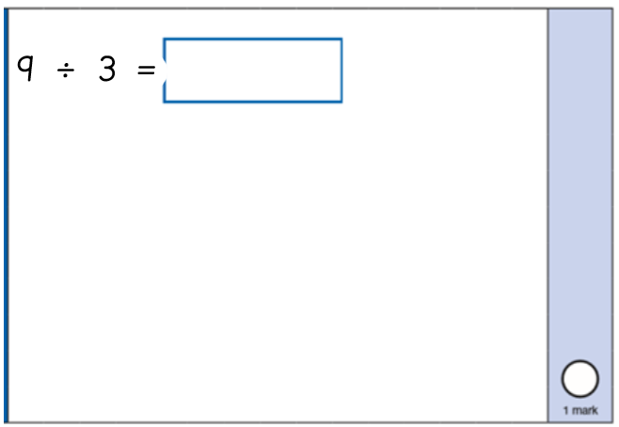 | 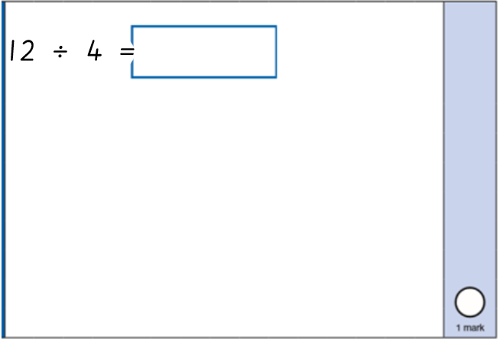


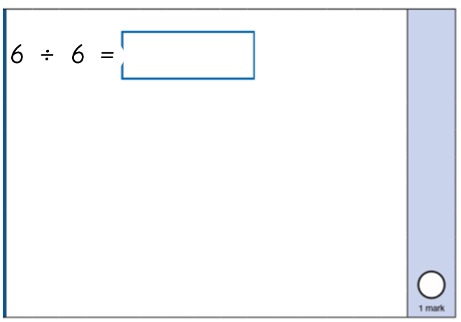 | 

