Home Learning Plans
Beech Class
Week Beginning: Monday 15th June
Reading:
- This Friday, at 9:30am, we are hoping to use Google Meet to start a new class story. We will be reading Chapters 1 and 2 of Matilda. We will send out a parent-pay message with a link, which you can use to join our meeting. This is our first attempt at a class meeting of this nature, so please be patient with us. (Alternatively, you can watch a recorded version of Chapters 1 and 2 on the school you tube channel.)

- Complete the reading comprehension questions for Chapters 1 and 2 of Matilda.

- Sign up for this year’s Summer Reading Challenge. It started on Friday 5 June and runs throughout the summer holidays, finishing at the end of September. It is aimed at children aged 4 – 11 and is completely free! The challenge features games, quizzes and downloadable activities to incentivise and encourage children and their families to take part in reading related activities at home. Children can choose their own reading goals, create book reviews, play games and collect virtual rewards. Parents and guardians can register their children online at www.sillysquad.org.uk
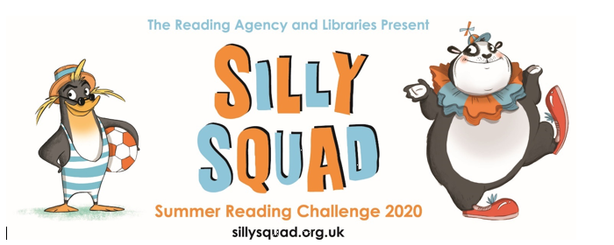

- Visit the Oxford Owl website. https://www.oxfordowl.co.uk/ Click on the My Class Login section

Use the following details to log in to the newly created beech class section.
Username: beechclass101
Password: pupil
Click on the ‘My Bookshelf’ section and select reading books that are right for you. Use the ‘Age Groups’ section to help narrow down the search.

- When completing guided or supported reading of an age appropriate text, focus on predictive questioning. Use the predictive section of this questioning tool to generate questions that challenge your child to predict what will happened in the story.

For example:
-What might happen next?
-Who could come with them?
-Where should they go?

- JK Rowling is publishing chapters from her new children’s book ‘The Ickabob’ each day on the following website: https://theickabog.com/
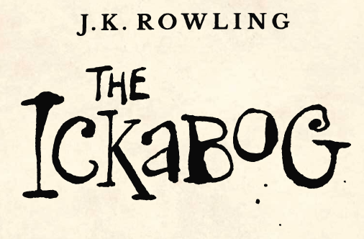
She is also asking children to send in their own illustrations that can be used in the book when it is published. Details for how to enter to illustration competition are on the website.

Spelling:
- Log on to Purple Mash and complete the spelling ‘2Dos’ which have been selected for you.

Writing/Topic/Science
Last week you completed a Local Habitat Study. If you did not complete this activity, go back and have a go at the Week 9 Writing/Topic/Science activities before you try this week’s activity.
- Watch this video and read the article on plant and animal adaptation:
https://www.bbc.co.uk/bitesize/topics/zvhhvcw/articles/zxg7y4j
- Use the understanding that you gained from watching the above video to compete the ‘Animal and Plant Adaption’ activity.
- Watch the ‘because/so conjunctions’ learning video.
- Complete the ‘because so game’ activity. Pick a pair of clauses from the sheet. Player A joins them verbally using the ‘because’ conjunction. Player B joins them using the ‘so’ conjunction. (This game is modelled on the ‘because/so conjunctions’ learning video)
EXTENSION: If you want to expand this game further, you can create your own pairs of clauses which can be joined using the because/so conjunctions.
- Use the understanding that you gained from watching the animal adaption video and the ‘because/so conjunctions’ learning video to write sentences which explain how a plant or animal from your local habitat has adapted to suit to its environment.
- Use the understanding that you gained from watching the animal adaption video and the ‘because/so conjunctions’ learning video to write sentences which explain how a plant or animal from an unfamiliar habitat has adapted to suit to its environment.
Please send the sentences that you complete to the class email address. We would like to use these sentences as part of next week’s learning pack. Also we would like to post them on the Class Blog.

Maths:
This week we are going to turn our attention to division.
- Watch the ‘Division’ learning video.
- Complete the ‘Division Problems with Low Dividends’ activity.
- Compete the ‘Division Problems with Large Dividends’ activity.
Extension: Complete the ‘Division Efficient Method’ activity.
- Complete the ‘Division by grouping and sharing’ Maths with Parents activity. Class code 233033
- Log on to Mymaths and complete the following activities:
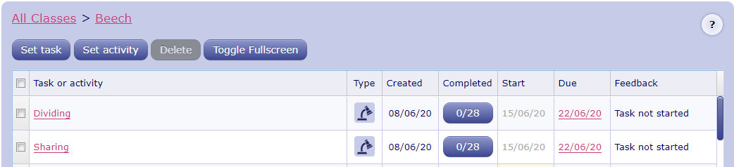

Number Fluency: This week we are going to focus on doubling and halving for the numbers up to 20.
- Watch the doubling and halving learning video.
- Use the ‘doubling and halving cards’ to practise you doubles and halves for the numbers up to 20.
- Cut along the dotted lines on the ‘Doubles and Halves’ activity. Pick out a strip and use the numicon images to help create as many different double and half statements as possible. e.g.
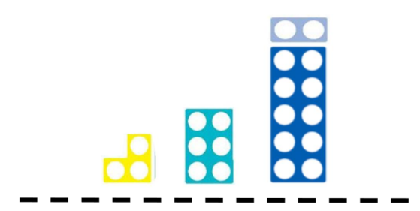
-Double 3 is 6.
-Double 6 is 12.
-Half of 12 is 6.
-Half of 6 is 3.
Repeat this with all of the different strips.

Wider Curriculum
- Pick activities of your choice from the wider curriculum matrix.

