Can you find these plants/animals/insects in a habitat close to your house (Grosvenor and Hilbert Park) for example?
Use the learning that you have gained from the adaption learning video to explain how these different plants/animals/insects have adapted to suit their environment.

Plant/Animal | Key Feature |  | How has it adapted to suit its habitat
Ivy  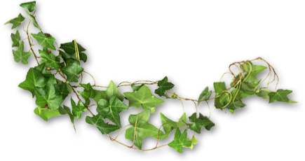 |  |  | ___________________________________  ___________________________________  ___________________________________  ___________________________________  ___________________________________
Squirrel  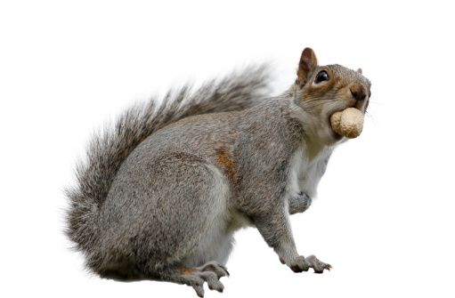 |  |  | ___________________________________  ___________________________________  ___________________________________  ___________________________________  ___________________________________
Oak Tree  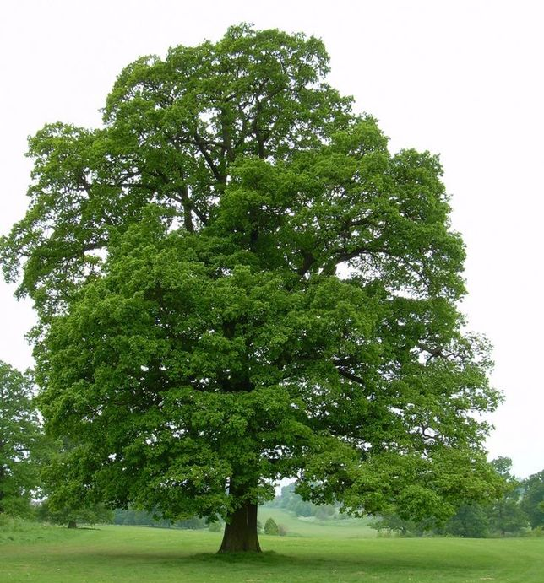 |  |  | ___________________________________  ___________________________________  ___________________________________  ___________________________________  ___________________________________  ___________________________________
Water Boatmen                  

