Use your understanding of odd and even numbers, multiples of 2,5 and 10 and Venn Diagrams to place the following numbers into each Venn Diagram.

7 12 5 25 10 21 30

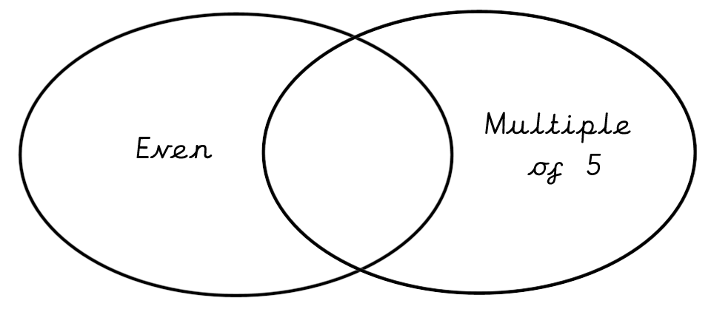

9 12 10 40 37 22

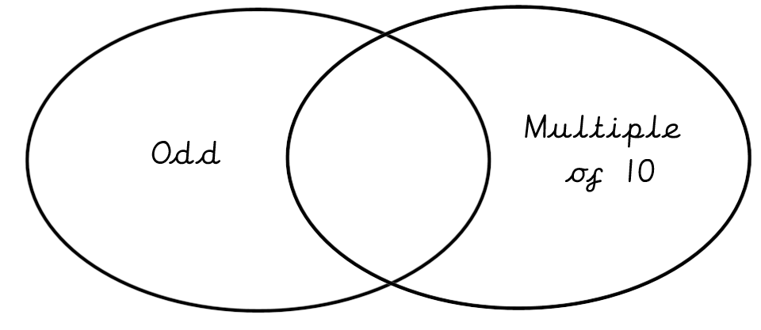

6 12 5 45 10 19 22

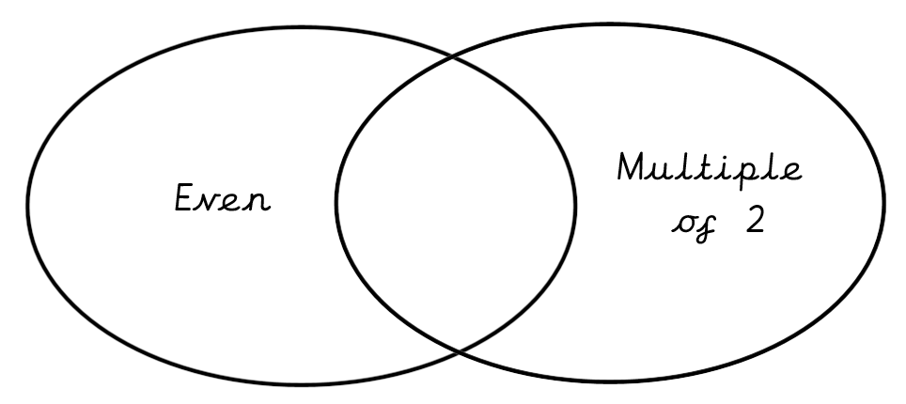

Extension:
Can you add an extra number to each section in every Venn Diagram?
Are there any sections where it is impossible to add a number? Why?

