Home Learning Plans
Beech Class
Week Beginning: Monday 18th May
Reading:
- If you have not done so already, please take some time as a family to explore The Book of Hopes. https://literacytrust.org.uk/family-zone/9-12/book-hopes/

- Visit the Literacy Trust Family Zone and follow the link to our Author of the Week- Tony Ross. https://literacytrust.org.uk/family-zone/author-week-family-zone/
-Watch 'I don’t want to wash my hands!' and download a FREE Little Princess book.
-Complete the ‘Learn how to draw the Little Princess’ Activity.
-Visit the following site and complete the 2016 SATs reading paper- ‘Meet Tony Ross’ https://www.satspapers.org.uk/Page.aspx?TId=4
-Visit the Little Princess Youtube channel to watch clips of the Little Princess’ latest antics and adventures.
https://www.youtube.com/user/IFCLondon/featured

- Visit the Oxford Owl website. https://www.oxfordowl.co.uk/ Click on the My Class Login section

Use the following details to log in to the newly created beech class section.
Username: beechclass101
Password: pupil
Click on the ‘My Bookshelf’ section and select reading books that are right for you. Use the ‘Age Groups’ section to help narrow down the search.

- When completing guided or supported reading of an age appropriate text, focus on analytical questioning. Use the analytical section of this questioning tool to generate questions that challenge your child to analyse what has happened in the story.

- For example:
-Why did they do that?
-How can you tell that…?

- If you haven’t done so already, join Julia Donaldson on Facebook every Thursday at 4pm. https://www.facebook.com/OfficialGruffalo/

Spelling:
- Log on to Purple Mash and complete the spelling ‘2Dos’ which have been selected for you.

Writing:
This week we are going to use a ‘Talk for Writing’ resource to inspire some drawing and writing activities. This week we will focus on the pages 4 to 12.
https://www.talk4writing.co.uk/wp-content/uploads/2020/04/Y2-Unit.pdf
- Read page 4 and 5 of the Magical Box workbook. (Ask for help from an adult if you need it) What do you think the box looked like? Use your imagination to draw a picture of what you think the box might have looked like.
- Start reading page 6. Stop when instructed and ask yourself the question: What might be in the box? Use a blank piece of paper to draw or write your ideas.
- Complete reading page 6 and 7. Use your imagination to draw ‘The Evil’ that came out of the box.
- Share the story with someone at home. Talk about it and then decide how you want to retell it. You could retell it verbally, use writing or design a comic strip. It is totally up to you.
- Read page 8. Sketch Zeus and label the features listed.
- Read the questions on page 9 and answer them in full sentences.
- Complete the vocabulary activities on page 10 and 11.
- Read each sentence on page 12. Write a sentence of your own using each piece of key vocabulary.

Maths:
This week we are going to continue and complete our fractions revision.
- Visit the White Rose Maths website- find the Home Learning Year 2- section.
https://whiterosemaths.com/homelearning/year-2/
Scroll down to find Week 2.

- Lesson 1 - Recognise a third. Watch the video: https://player.vimeo.com/video/401120027
Complete the activity and check your answers.

- Lesson 2 - Find a third. Watch the video:
https://player.vimeo.com/video/401120153
Complete the activity and check your answers.

- Lesson 3 - Unit fractions. Watch the video:
https://player.vimeo.com/video/401120349
Complete the activity and check your answers.

- Lesson 4 - Non-unit fractions. Watch the video: https://player.vimeo.com/video/401120499
Complete the activity and check your answers.

- Lesson 5 - Equivalence of a half and 2 quarters. Watch the video: https://player.vimeo.com/video/401120613
Complete the activity and check your answers.

- Log on to MyMaths- https://www.mymaths.co.uk/ Complete the following MyMaths activities
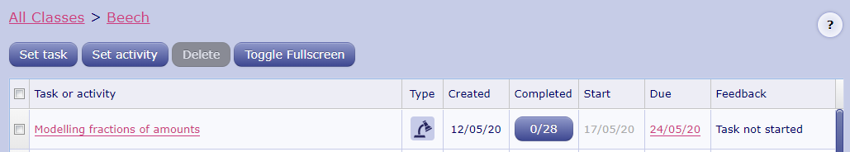
IMPORTANT: Currently, approximately half the class are regularly completing MyMaths activities. If you need your password or help logging on and using this resource, please contact us via the class email address beech@st-barnabas.kent.sch.uk
- Complete the ‘Unit Fractions With Visual Support’ Activity.
- Complete the ‘Fractions of Shapes and Notation Challenge’ Activity.
- Complete the ‘Fractions of Amounts Challenge’ Activity.

Number Fluency:
- Watch the ‘Multiplication and Division Fact Families’ learning video:
- Complete the ‘Fact families for multiplication and division’ Maths With Parents activity- class code: 233033
- Log on to Times Tables Rockstars and start practising your multiplication and division facts for the 1 2, 5 and 10 times tables. Use your learning from the ‘fact family’ activities to help you work out the division facts.
IMPORTANT: If you feel that your child has mastered these times tables and requires a new challenge, please contact us via the class email address: beech@st-barnabas.kent.sch.uk so we can allocate a new level of challenge for your child.

Science Week:
- This week is Science Week! Use the separate plans to help select a range of different practical, hands on scientific activities to enjoy with your family. Don’t forget to count up your Science Week Electrons so that you can claim your Science Week certificate.
If you have any questions or queries relating to Science Week or any of the activities detailed on these plans. Please use the class email address to get in touch.

