Home Learning Plans
Beech Class
Week Beginning: Monday 11th May
Reading:
- Spend some time as a family exploring The Book of Hopes. https://literacytrust.org.uk/family-zone/9-12/book-hopes/

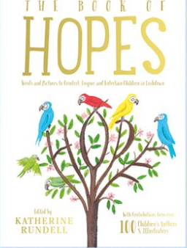
This extraordinary collection of short stories, poems, essays and pictures has contributions from more than 110 children’s writers and illustrators, including Lauren Child, Anthony Horowitz, Greg James and Chris Smith, Michael Morpurgo, Liz Pichon, Axel Scheffler, Francesca Simon and Jacqueline Wilson.
The collection, published by Bloomsbury, is dedicated to the doctors, nurses, carers, porters, cleaners and everyone currently working in hospitals.
- Listen in to Mr M as he reads the final chapters from our current class story, ‘George’s Marvellous Medicine.’ https://youtu.be/CGNS5PYvzO4
- Visit the Oxford Owl website. https://www.oxfordowl.co.uk/ Click on the My Class Login section
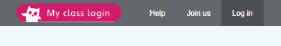
Use the following details to log in to the newly created beech class section.
Username: beechclass101
Password: pupil
Click on the ‘My Bookshelf’ section and select reading books that are right for you. Use the ‘Age Groups’ section to help narrow down the search.
- When completing guided or supported reading of an age appropriate text, focus on predictive questioning. Use the predictive section of this questioning tool to generate questions that challenge your child to predict what has happened in the story.

- For example:
-What might happen next?
-Who could come with them?
-Where should they go?
- Julia Donaldson, writer of The Gruffalo series, Stick Man and Zog, has announced a new weekly online broadcast featuring stories, songs and poems, broadcast on Facebook from her home every Thursday at 4pm. https://www.facebook.com/OfficialGruffalo/

Spelling
- Log on to Purple Mash and complete the spelling ‘2Dos’ which have been selected for you.

Writing:
Last week you spent time writing a letter to your new Vietnamese pen-pal, Bao Quyen or Loc. If you have created digital copies of these letters, please send them to me (beech@st-barnabas.kent.sch.uk) and I will forward them to the British International School in Ho Chi Minh City. This week, we would like you to pick a pen-pal of your choice and write to them.
- Fill in the ‘Me’ section of the ‘Me and My New Pen Pal Information Sheet’ Activity. Record important and interesting pieces of information relating to:
-Your personal information (name, age, family etc)
-Your hobbies and interests
-Your school
-Your hometown
- Decide who your new pen pal is going to be. Fill in any information that you already know about them into the ‘My New Pen-Pal’ section of the information sheet. If you don’t know much about them, add the questions that you would ask to get the information you need. e.g. What are your hobbies or interests?
- Go back and re-read Mr M’s modelled letter to his Vietnamese Pen-Pal and your own letter to your Vietnamese pen-pal. If you need help to remember how and why these letters were successful, re-watch the ‘Letter to your pen-pal’ learning video. https://youtu.be/HgdYgZoOhlg
- Write a letter to your new pen-pal. Use this success criteria to make sure your letter is successful:
-I can include the organisational features of a letter.
-I can write a short introduction to explain who I am and why I am writing.
-I can use a topic sentence to introduce each paragraph.
-I can use conjunctions to add clauses to my sentences.
-I can use exclamation sentences to add extra emphasis.
-I can use questions aimed directly at my audience.
- Mark your letter against the success criteria using pink and green pen. Redraft your letter using the green areas to make improvements.
- Send your letter to your new pen-pal and keep your fingers crossed for a response.

Maths:
This week we are going to revisit and cement our understanding of fractions.
- Visit the White Rose Maths website- find the Home Learning Year 2- section.
https://whiterosemaths.com/homelearning/year-2/
Scroll down to find Week1.
- Lesson 1 - Make equal parts. Watch the video: https://player.vimeo.com/video/398556944
Complete the lesson 1 Activity- check your answers and make any necessary improvements.
- Lesson 2 - Recognise a Half. Watch the video: https://player.vimeo.com/video/398556991
Complete the lesson 2 Activity- check your answers and make any necessary improvements.
- Lesson 3- Find a half. Watch the video:
https://player.vimeo.com/video/398557553
Complete the lesson 3 Activity- check your answers and make any necessary improvements.
- Lesson 4 - Recognise a quarter. Watch the video:
https://player.vimeo.com/video/398557579
Complete the lesson 4 Activity- check your answers and make any necessary improvements.
- Lesson 5 - Find a quarter. Watch the video:
https://player.vimeo.com/video/398557774
Complete the lesson 5 Activity- check your answers and make any necessary improvements.
- Complete the ‘Fractions of Quantity and Shape’ Maths with Parents Activities- class code 233033
IMPORTANT: So far only 12 children in Beech Class are signed up to Maths with Parents. This is a shame as it is a resource that is normally fairly expensive but is being offered to us for free by the company who make it. If you need help or guidance on how to sign up for this resource please contact us via the class email address beech@st-barnabas.kent.sch.uk
- Log on to MyMaths- https://www.mymaths.co.uk/ Complete the following MyMaths activities
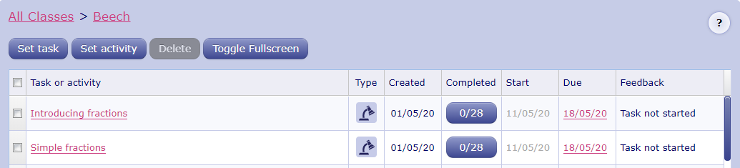
IMPORTANT: Currently, approximately half the class are regularly completing MyMaths activities. If you need your password or help logging on and using this resource, please contact us via the class email address beech@st-barnabas.kent.sch.uk
- If you are looking for extra fractions challenges, why not try the following fractions activities on the nrich website:
https://nrich.maths.org/2361
https://nrich.maths.org/10359
https://nrich.maths.org/1788

Number Fluency
- Watch the ‘Number Bonds to 10’ learning video. https://youtu.be/y2lv1lt2k3U
- Complete the Number Bonds Activities
- Complete the ‘Number Bonds Arithmetic Challenge’ Activity.
- Log on to Times Tables Rockstars and start practising your multiplication and division facts for the 1 2, 5 and 10 times tables.
IMPORTANT: If you feel that your child has mastered these times tables and requires a new challenge, please contact us via the class email address: beech@st-barnabas.kent.sch.uk so we can allocate a new level of challenge for your child.

Wider Curriculum
- Pick activities of your choice from the Wider Curriculum Home Learning Matrix.

