Wider Curriculum Home Learning Matrix: (2 Weeks)
Weeks Beginning: 4th and 11th May
Friday 8th May is a very important day, it marks the 75th Anniversary of VE Day. We invite all members of the St Barnabas Community to learn about VE Day and take part in the VE Day 75th Anniversary ‘Stay at Home Street Party’. As well as your regular wider curriculum activities, we have added some VE Day specific activities on to this planning grid.
You can give your child a quick introduction to VE Day by reading and discussing the following Newsround article with them:
https://www.bbc.co.uk/newsround/48201749

 | Create | Investigate | Explain | Perform
Science and Computing | Create a food chain for a habitat of your choice.  Make sure you label each part of the food chain with the appropriate scientific vocabulary. Here are some of the words you might need to use:  -Producer  -Consumer  -Primary Consumer  -Secondary Consumer  -Tertiary Consumer  -Prey  -Predator | Investigate food chains. This video might help:  https://www.bbc.co.uk/bitesize/topics/ zbnnb9q/articles/zwbtxsg  Can you gain an understanding of the following pieces of key vocabulary:  -Producer  -Consumer  -Primary Consumer  -Secondary Consumer  -Tertiary Consumer  -Prey  -Predator | Complete these food chain challenges:  https://www.bbc.co.uk/bitesize/ topics/zbnnb9q  -Savannah  -Tundra  -Woodland  Explain to a member of your family how the food chain works in one of these habitats. Remember, you can use pictures and diagrams to help you. | Test your understanding of food chains by completing the ‘Food Chain’ 2Do that has been set for you on PurpleMash.  Can you design a quiz of your own to challenge a family member’s understanding of food chains?
Time and Place | Since the end of WWII, graphic designers and artists have created a variety of posters to  celebrate VE Day.   Create a poster to celebrate the 75th Anniversary of VE day. | With the help of a grown up, use secondary sources of information to investigate World War II. You might find the following websites useful:  https://www.natgeokids.com/uk/discover/  history/general-history/world-war-two/  https://www.dkfindout.com/uk/history/world-war-ii/  https://www.iwm.org.uk/history/  growing-up-in-the-second-world-war | Use your knowledge of WWII to answer the question:  What is VE Day?  Present your ideas in a way of your choosing:  -verbal presentation  -mind map  -concept map  -information text | On 8th May 1945 we are inviting you and your family to take part in your very own ‘Stay at Home Street Party’. Here are some suggestions:  -decorate your house in red, white and blue  -get into character  -dress up in 1940s clothes.  -listen to 1940s music  -have a celebratory picnic  Please send us your pictures if you can!
Design and the Arts | Take inspiration from a map of your local area. Use it to create a piece of art in the style of the Vietnamese artist Tiffany Chung. | Complete an image search for the Vietnamese artist Tiffany Chung  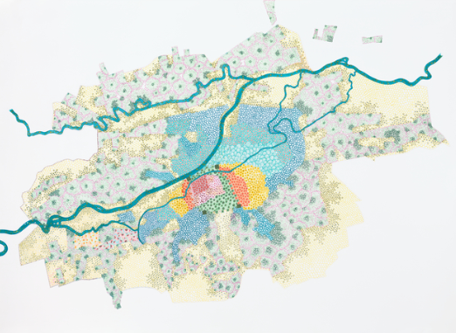  Explore the way that she uses maps as an inspiration for her art.  How do you think she makes these pieces of art? How might she use maps? What materials might she use? How might she apply the colour? | Create a step by step explanation for how you created your Tiffany Chung inspired piece of art. | Take part in the VE Day sing along.
Religion and Values | Rest, prayer and time with family are very important in the Jewish faith.  Create a diary of a day in your life. Use colour to indicate periods in which you are busy and restful.  At the end of the day reflect on these different periods and consider how they made you feel. | Investigate how Jewish people observe Shabbat and the different traditions and practices that take place during Shabbat.  Watch this video to help:  https://www.bbc.co.uk/programmes/p0114f7y | Explain why the candle that is lit to mark the end of Shabbat (Havdalah) is braided with multiple wicks. | The home is central to the passing on of traditions in the Jewish faith. Many religious practices and festivals are observed at home by parents and children, rather than at the synagogue.  The observance of Shabbat and especially the lighting of the candles of Friday night and enjoying a meal together is one of the strongest examples of Jewish life.  Can you and your family set up your own family tradition?
Sport Exercise and Health | Start the day in the traditional Vietnamese way. With the help of an adult, make you and your family a traditional Vietnamese Bánh mì for breakfast. | The most popular Vietnamese breakfast snack is, without doubt the Bánh mì sandwich.  Use the internet to find a Bánh mì recipe that you like the look of. Record down all the ingredients and instructions. | Write a set of instructions for how to make the perfect Vietnamese Bánh mì. | In cities and towns across Vietnam, it is a very common sight to see large numbers of local people, congregating at sunrise to perform communal exercise routines.  Can you persuade anyone in your family to join you in your own sunrise exercise routine?
Outdoor Learning | Create a tally chart, pictogram or block diagram which records the wildlife you spotted in a local woodland habitat. | Take a walk around a local woodland habitat, Grosvenor and Hilbert park for example. Record all the birds, animals and insects that you recognise. If you spot something that you do not recognise, use the internet to try to find out what it was. | Explain how the wildlife you spotted in your local woodland habitat fits into a food chain. | Present what you have found out by exploring a local woodland habitat to someone in your household or organise a face-time/skype meeting to explain it to someone not in your household.

