Home Learning Plans
Beech Class
Week Beginning: Monday 4th May
Reading:
- As this is our 5th week of home learning plans, we understand that some of you might be looking to mix things up a little. Therefore, we have attached the following link for you to explore: https://literacytrust.org.uk/family-zone/

The National Literacy Trust has developed a comprehensive web portal for parents, to support you during this time. Please explore this fantastic site and let us know what you think.

- Listen in to Mr M as he reads the next two chapters from our current class story, ‘George’s Marvellous Medicine.’ https://youtu.be/vSINpd-gY7U
- Visit the Oxford Owl website. https://www.oxfordowl.co.uk/ Click on the My Class Login section
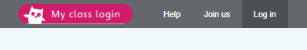
Use the following details to log in to the newly created beech class section.
Username: beechclass101
Password: pupil
Click on the ‘My Bookshelf’ section and select reading books that are right for you. Use the ‘Age Groups’ section to help narrow down the search.
- Visit the website that stores all the past Year 2 SATs papers: https://www.satspapers.org.uk Click on KS1 Year 2 SATs papers and scroll down to find the 2016 Sample English Reading Paper. Complete the ‘Plastics and the Environment’ comprehension activity. If you find this very challenging, work through it with the support of an adult.
- When completing guided or supported reading of an age appropriate text, focus on factual questioning. Use the factual section of this questioning tool to generate questions that challenge your child to apply or synthesise what has happened in the story.

For example:
--When did the character go to the shops?
-What did they do next?
-Who is in the shop?
-Where are the characters going?
- Julia Donaldson, writer of The Gruffalo series, Stick Man and Zog, has announced a new weekly online broadcast featuring stories, songs and poems, broadcast on Facebook from her home every Thursday at 4pm. https://www.facebook.com/OfficialGruffalo/

Spelling
- Log on to Purple Mash and complete the spelling ‘2Dos’ which have been selected for you.

Writing: This week we are moving onto a new genre of writing linked to our ‘At Home and Abroad’ topic. This week, we are going to write letters to a Vietnamese pen-pal.
- Fill in the ‘Me’ section of the ‘Me and My Pen Pal Information Sheet’ Activity. Record important and interesting pieces of information relating to:
-Your personal information (name, age, family etc)
-Your hobbies and interests
-Your school
-Your hometown
- Use the following link to watch videos introducing your Vietnamese pen-pals; Bao Quyen in Year 1 and Loc in Year 8. https://www.nordangliaeducation.com/en/our-schools/vietnam/ho-chi-minh-city/bvis/our-students/meet-our-students
- Pick one of these children to be your pen-pal. Use the information from the videos to fill in any information that you can in the ‘My Vietnamese Pen-Pal’ section of the information sheet. If he/she doesn’t give you enough information, add the questions that you would ask to get the information you need. e.g. Do you have any brothers or sisters?
- Carefully read Mr M’s modelled letter to his Vietnamese Pen-Pal.
- Watch ‘Letter to your pen-pal’ learning video. https://youtu.be/HgdYgZoOhlg
- Write a letter to your Vietnamese pen-pal. Use this success criteria to make sure your letter is successful:
-I can include the organisational features of a letter.
-I can write a short introduction to explain who I am and why I am writing.
-I can use a topic sentence to introduce each paragraph.
-I can use conjunctions to add clauses to my sentences.
-I can use exclamation sentences to add extra emphasis.
-I can use questions aimed directly at my audience.
- Mark your letter against the success criteria using pink and green pen. Redraft your letter using the green areas to make improvements. If you need help to remember how to mark and redraft your work, watch the learning video from Week 2.

Maths: This week we are continuing to learn about how to record and present data.
- Watch the ‘Block Diagram’ learning video. https://youtu.be/lXk5XSQkgNE
- Complete ‘Block Diagram Activity 1’
- Complete ‘Block Diagram Activity 2’
In order to read and interpret more complex block diagrams, we need to get really good at reading and interpreting scales.
- Watch the ‘Reading Scales’ learning video. https://youtu.be/XJicnxB-wEM
- Complete ‘Block Diagram Activity 3’
- Complete the ‘Block Diagrams and Pictograms’ Maths with Parents Activities- class code 233033
- Log on to MyMaths- https://www.mymaths.co.uk/ Complete the following MyMaths activities
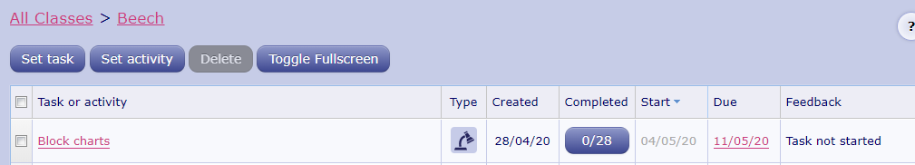
- Complete the ‘Statistics Problem Solving’ Activity.

Number Fluency
- If you have not done so already, use the ‘Making a Times Table Numberline’ resource to make your own set of cards for the 2, 5 and 10 times tables.
- If you have not done so already, watch the ‘Learning Your Times Tables’ learning video to help develop strategies for learning your tables. https://youtu.be/2Vday-SY8N0
- Log on to Times Tables Rockstars and start practising your multiplication and division facts for the 1 2, 5 and 10 times tables.
IMPORTANT: If you feel that your child has mastered these times tables and requires a new challenge, please contact us via the class email address: beech@st-barnabas.kent.sch.uk so we can allocate a new level of challenge for your child.
- Log on to Purple Mash and complete the Bond Bubbles ‘2Dos’ which has been selected for you to help practise your number bonds.

Wider Curriculum
- Pick activities of your choice from the Wider Curriculum Home Learning Matrix.

