Home Learning Plans
Beech Class
Week Beginning: Monday 27th April
Reading:
Join in with Mr M as he reads the next chapter from our current class story, ‘George’s Marvellous Medicine.’ https://youtu.be/HS53Jxlxrp0
Stop the video playing when instructed and answer the comprehension questions.
- Visit the Oxford Owl website. https://www.oxfordowl.co.uk/ Click on the My Class Login section
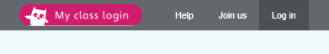
Use the following details to log in to the newly created beech class section.
Username: beechclass101
Password: pupil
Click on the ‘My Bookshelf’ section and select reading books that are right for you. Use the ‘Age Groups’ section to help narrow down the search.
- Visit the website that stores all the past Year 2 SATs papers: https://www.satspapers.org.uk Click on KS1 Year 2 SATs papers and scroll down to find the 2017 English Reading Paper. Complete the ‘Swim Spray Swimming Pool?’ comprehension activity. If you find this very challenging, work through it with the support of an adult.
- When completing guided or supported reading of an age appropriate text, focus on application/synthesis questioning. Use the application/synthesis section of this questioning tool to generate questions that challenge your child to apply or synthesise what has happened in the story.

For example:
-Why should they do that?
-Why might they not want to do that?
-How might the character feel here?
Spelling
- Log on to Purple Mash and complete the spelling ‘2Dos’ which have been selected for you.

Writing:
- Last week you should have completed a piece of recount writing focusing on the flowing skills
-headings/subheadings
-adverbials which express time
- conjunctions to add clauses to your sentences.
-adjectives to create expanded noun phrases
If you missed out any of these skills, go back and look at the learning videos from week 3.
- Read Mr M’s next recount: A Trip to Scotland. Pay particular attention to the following pieces of success criteria:
-exclamation sentences.
-sentences which communicate directly to the reader.
Then Watch the learning video. https://youtu.be/jeJ7um5LEKk
- Create a piece of writing which recounts a special trip that you have been on in the past. Try to find pictures to help remind you of what you did. Work hard to produce a piece of writing that includes all of the following pieces of success criteria:
-headings/subheadings
-adverbials which express time
- conjunctions to add clauses to your sentences.
-adjectives to create expanded noun phrases
-exclamation sentences.
-sentences which communicate directly to the reader.
- Use pink and green pen to mark your work against the success criteria provided. If you need help to remember how to do this, watch the redrafting learning video from Week 2.
- Redraft your recount, making improvements to all the green areas. Make sure that your final draft meets all of the success criteria.

Maths: This week we are learning about how to record and present data.
- Watch the learning video explaining how to create tally charts. https://youtu.be/5M9SYtSexm4
- Complete Tally Chart Activity 1
- Complete Tally Chart Activity 2
- Watch the learning video explaining how to create pictograms. https://youtu.be/woYA76_zXyw
- Complete the ‘Pictograms’ Activity. You can use the ‘Pictograms Completed’ resource to check your answers.
- If you are looking for an additional challenge relating to pictograms, try the ‘Pictograms’ extension activity.
- Log on to MyMaths- https://www.mymaths.co.uk/ Complete the following MyMaths activities
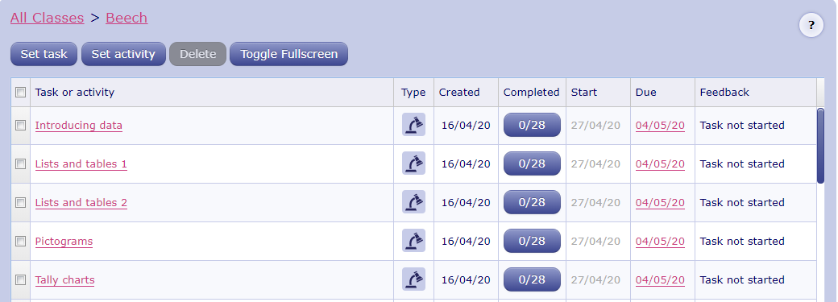
- Create your own tally chart and pictogram.
Step 1: Select the data that you wish to collect. For example, the colour of the cars on your street.
Step 2: Use a tally chart to collect your data.
Step 3: Present this data as a pictogram.
Remember to label your pictogram clearly and think carefully about how many items each picture should represent. If you find this bit tricky, ask an adult to support you.

Number Fluency
- Use the ‘Making a Times Table Numberline’ resource to make your own set of cards for the 2, 5 and 10 times tables.
- Watch the ‘Learning Your Times Tables’ learning video to help develop strategies for learning your tables. https://youtu.be/2Vday-SY8N0
- Log on to Times Tables Rockstars and start practising your multiplication and division facts for the 1 2,, 5 and 10 times tables.
- Log on to Purple Mash and complete the Bond Bubbles ‘2Dos’ which has been selected for you to help practise your number bonds.

Wider Curriculum
- Pick activities of your choice from the Wider Curriculum Home Learning Matrix.

