Here are the skills that I focussed on:

I can use headings and/or subheadings to organise my ideas.
I can start sentences with adverbials which express time.

Building a Shed
On the first weekend of the Easter holidays, my dad and I built a shed. First of all, we dug some holes to put up strong fence posts. It was really difficult because it rained very hard and the garden was very muddy.
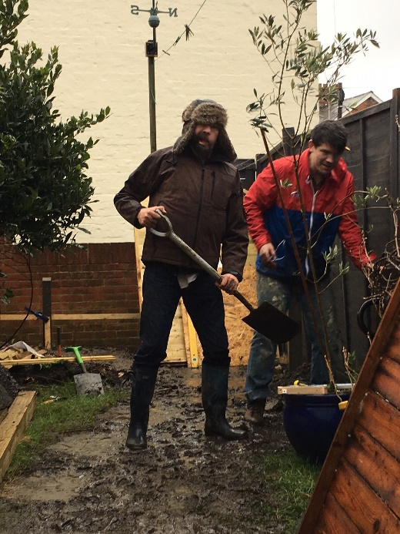
After we put up the fence posts, we fitted a new fence panel and gate. We had to make sure everything was straight and all the screws were done up tightly. What a difficult job it was!

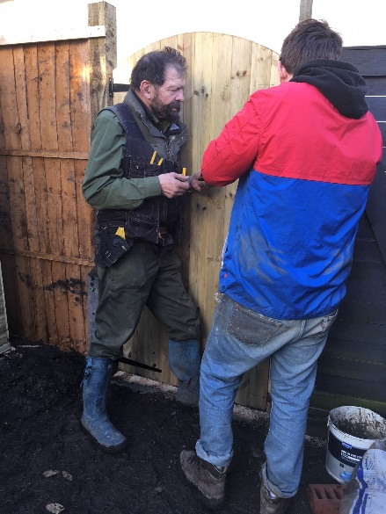
When we had finished the gate, we built a new shed to keep all our garden tools safe. It took quite a long time but in the end we got it finished.
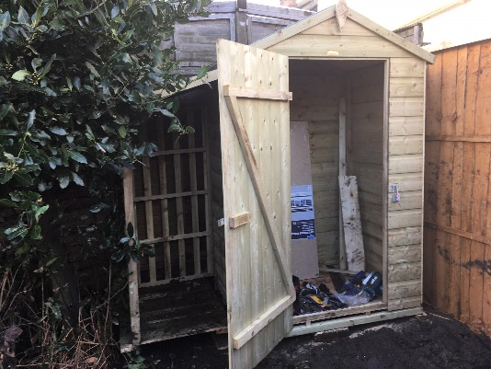
While my dad and I were building the shed, my mum looked after baby Alfred. She read him lots of brilliant books because he loves to listen to stories.
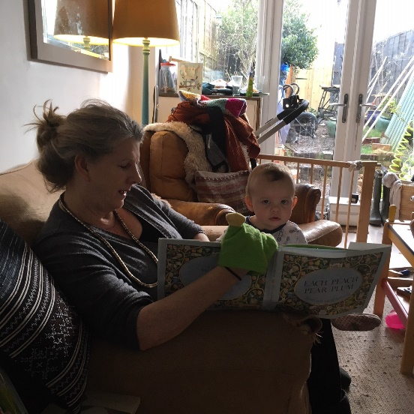
Building a shed was really good fun. Have you ever built anything in your back garden?

