Home Learning Plans
Beech Class
Week Beginning: Monday 20th April
Reading:
Join in with Mr M as he reads the next chapter from our current class story, ‘George’s Marvellous Medicine.’ https://youtu.be/s6y8M6PfbzI
Stop the video playing when instructed and answer the comprehension questions.
- Visit the Oxford Owl website. https://www.oxfordowl.co.uk/ Click on the My Class Login section
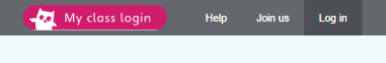
Use the following details to log in to the newly created beech class section.
Username: beechclass101
Password: pupil
Click on the ‘My Bookshelf’ section and select reading books that are right for you. Use the ‘Age Groups’ section to help narrow down the search.
- Visit the website that stores all the past Year 2 SATs papers: https://www.satspapers.org.uk Click on KS1 Year 2 SATs papers and scroll down to find the 2019 English Reading Paper. Complete the ‘Liam the Park Keeper?’ comprehension activity. If you find this very challenging, work through it with the support of an adult.
- When completing guided or supported reading of an age appropriate text, focus on analytical questioning. Use the analytical section of this questioning tool to generate questions that challenge your child to analyse what has happened in the story.

For example:
-Why did they do that?
-How can you tell that…?
Spelling
- Log on to Purple Mash and complete the spelling ‘2Dos’ which have been selected for you.

Writing:
- This week we are moving on to a new genre of writing- Recount writing.
- Read Mr M’s recount of the time that he and his father built a shed in his back garden. Look closely at the yellow and grey highlighted areas.
- Watch the learning video which covers the following pieces of success criteria:
https://youtu.be/X5xRZokZTyI
I can use headings and/or subheadings to organise my ideas.
I can start sentences with adverbials which express time.
- Build something in your back garden (if you don’t have a garden you can do this in your living room). It could be a fort or a mini-allotment or a play area. The choice is up to you. Once you have completed your construction, take a photo of it and email it to the class email account. beech@st-barnabas.kent.sch.uk
- Create a piece of writing which recounts the experience of building your construction. Make sure your writing includes headings/subheadings and adverbials which express time.
- Read Mr M’s recount of his son Alfred’s birthday. Look closely at the red and light blue highlighted areas.
- Watch the learning video for the following pieces of success criteria: https://youtu.be/F-pWxVe3yvs
I can use conjunctions to add clauses to my sentences.
I can use adjectives to create expanded noun phrases.
- What did you do for your last Birthday? Write a recount of it using:
-headings/subheadings
-adverbials which express time
- conjunctions to add clauses to your sentences.
-adjectives to create expanded noun phrases
Remember, we would love to read your recounts, so type them up/photograph them and send them to us via email. beech@st-barnabas.kent.sch.uk
If you do, we will send you back some pink and green feedback.
Maths: This week we are learning about measurement.
- Complete the ‘Measuring Capacity and Volume’ Maths with Parents Activities- class code 233033
- Complete the ‘Measuring Length’ Maths with Parents Activities- class code 233033
- Complete the ‘Measuring Mass’ Maths with Parents Activities- class code 233033
- Log on to MyMaths- https://www.mymaths.co.uk/ Complete the following MyMaths activities
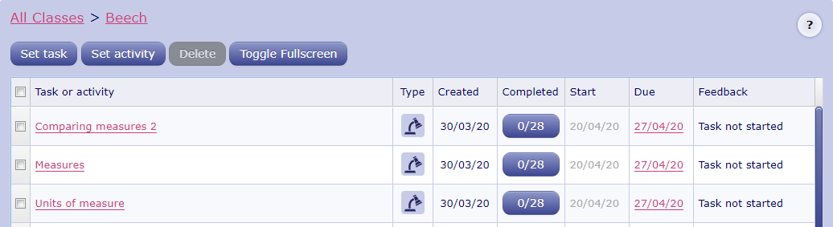
- Complete the ‘Mass, Capacity and Temperature Problem Solving’ activity.
- Complete the ‘Measurement Problem Solving Challenges’ activity.
- Complete the ‘Bottle Challenge’ activity.

Number Fluency
- Log on to Purple Mash and complete the 10 times tables ‘2Dos’ which have been selected for you.
- Log on to Times Tables Rockstars and start practising your multiplication and division facts for the 1, 5 and 10 times tables.
- Watch the learning video for ‘Bridging through 10’ https://youtu.be/3CRCJ_wtsZg
Use this skill to solve the ‘Bridging through 10’ calculation worksheet. If you are looking for an extra challenge, use your understanding of bridging through 10 to solve the ‘Bridging through Multiplies of 10’ calculation worksheet.
IMPORTANT: If you find the bridging through 10 activity very challenging, do not worry! Just go back and practise the skills that support this technique:
-number bonds to 1,2,3,4,5,6,7,8,9 and 10
-using place value to add single digits to multiples of 10. e.g. 30 + 4 = 34
If you need help with these skills, email us and we will provide you with some additional help.

Wider Curriculum
- Pick activities of your choice from the Wider Curriculum Home Learning Matrix.

