I can use headings and subheadings to organise my ideas.
I can start sentences with adverbials which express time.
I can use conjunctions to add clauses to my sentences.
I can use adjectives to create expanded noun phrases.

Alfred’s Birthday

On Saturday 7th April, my wife, baby Alfred and I woke up feeling excited. It was Alfred’s first birthday! After we had eaten a breakfast, we got into our car and drove to Ascot. It was a long way but Alfred was really patient and well-behaved. After an hour and a half, we arrived at my wife’s mum’s house. How excited Alfred was to see his grandma!

At 12pm, the guests for the party arrived. Everyone brought some delicious food for lunch, as well as a present for Fred. Alfred was happy to see so many people, and waved at them when they arrived. However, he was too little to know how to open his presents. His Granny Sue and Grandpa Tim bought him a fantastic bag of toys, and his Uncle Ross bought him an interesting book.

In the afternoon, everyone ate lunch. The food was delicious! Then it was time for Alfred to have his birthday cake. After blowing out the candle, Alfred was given the whole cake and allowed to feed himself. First he put his hand inside. Then he licked his hand. Finally, he threw the crumbs around. He was smiling a lot, although he got very, very messy!

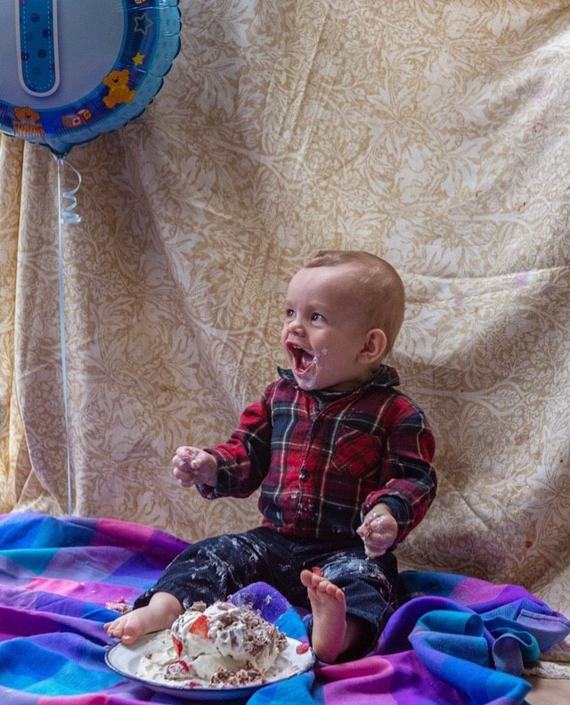

After lunch, Alfred played with his grandma’s fluffy dog, called Zim. Then, he started to feel tired. We got into the car so that Fred could sleep on the way home. He had had a wonderful first birthday and had lots of exciting presents to play with in the future. What a fantastic day it was! What did you do on your last birthday? Did you have fun?

