Home Learning Plans
Beech Class
Week Beginning: Monday 23rd March
Reading:
- Visit the following site https://connect.collins.co.uk/school/Portal.aspx
Click on the Teacher portal and enter
Username parents@harpercollins.co.uk
Password Parents20!
And click Login
Explore the different book banks and choose books which are right for you. If you want to study a book in more detail, click on the resources section for detailed notes on how to do so.
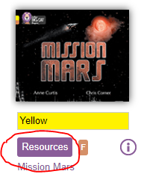
- Log on to Purple Mash and complete the Talking Stories ‘2Do’ which has been selected for you.
- Visit the website that stores all the past Year 2 SATs papers: https://www.satspapers.org.uk Click on KS1 Year 2 SATs papers and scroll down to find the 2019 English Reading Paper. Complete the ‘My Big Brother JJ’ comprehension activity. If you find this very challenging, work through it with the support of an adult.
- When completing guided or supported reading of an age appropriate text, focus on factual recall. Use the factual section of this questioning tool to generate questions to ensure that your child has fully understand what they are reading.

For example:
-When did the character go to the shops?
-What did they do next?
-Who is in the shop?
-Where are the characters going?
Spelling
- Log on to Purple Mash and complete the spelling ‘2Dos’ which have been selected for you.

Writing: This week we are learning about thankyou letters.
- Read the modelled letter that was sent out with this set of plans. Use this model to help you write a thankyou letter from one character to another in our quest. Here are some examples of the characters you might like to choose:
- Princess Clara to Sir Jack
-The King to Sir Jack
-The People of the Firelands Kingdom to Sir Jack
-Sir Jack to the Unicorn Prince
-Sir Jack to the Nobel Rabbit
- Write a thankyou letter to someone in your life. Try to follow the same structure that we have used to create the modelled pieces of writing
-Address of the sender
-Date of writing
-Who you are writing to
-Introduction explaining who you are and why you are writing
-1st reason to be thankful
-2nd reason to be thankful
-3rd reason to be thankful
-Conclusion
-Who the letter is from

Maths: This week we are learning about 2D and 3D shapes.
- Complete the 2D and 3D shape Maths with Parents Activities- class code 233033
- Find a range of 2D shapes around the house. Use the ‘Comparing Shapes Help Sheet’ to compare and contrast these shapes.
- Complete the ‘Comparing 2D Shapes’ worksheet
- Complete the ‘Always, Sometimes, Never’ worksheet.
- Log on to MyMaths- https://www.mymaths.co.uk/ Complete the following MyMaths activties
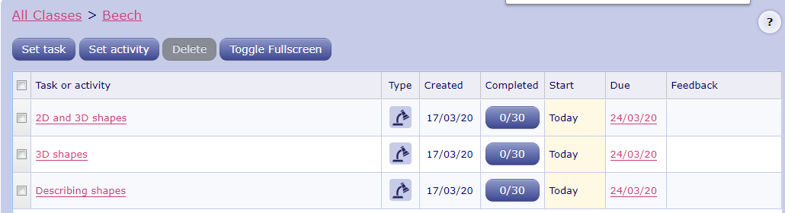

Number Fluency
- Log on to Purple Mash and complete the 2 times tables ‘2Dos’ which have been selected for you.
- Complete the number bonds Maths with Parents Activities- class code 233033

Wider Curriculum
- Pick activities of your choice from the Wider Curriculum Home Learning Matrix.

