Home Learning Plans
Willow Class
Week Beginning: Monday 15th June 2020

Dear Willow Class parents/carers and children,

The core learning for this week is set out below.

Reading
- Sign up for this year’s Summer Reading Challenge. It started on Friday 5 June and runs throughout the summer holidays, finishing at the end of September. It is aimed at children aged 4 – 11 and is completely free! The challenge features games, quizzes and downloadable activities to incentivise and encourage children and their families to take part in reading related activities at home. Children can choose their own reading goals, create book reviews, play games and collect virtual rewards. Parents and guardians can register their children online at www.sillysquad.org.uk
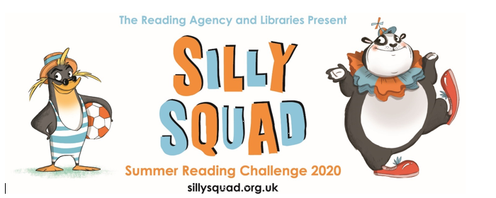

- All children should read an age appropriate text for a minimum of 20 minutes per day. This can be a reading book or sharing a picture book with an adult. When completing guided or supported reading of an age appropriate text, focus on predictive questioning. Use the predictive section of this questioning tool to generate questions that challenge your child to predict what will happened in the story.
For example: What might happen next? Who could come with them?
Where should they go? When might they go home?

You can also visit the Oxford Owl website. https://www.oxfordowl.co.uk/
Username: willow101
Password: pupil
Or you can use reading resources via https://connect.collins.co.uk/school/Portal.aspx
Click on the Teacher Portal and enter:
Username: parents@harpercollins.co.uk
Password: Parents20! And click Login

I have included reading comprehensions on Jazzy Jellyfish for you to complete.

Spelling/Phonics
This week’s spelling work focuses on compound words and I have set a spelling “Do on Purple Mash. Our phonics work will concentrates on alternative spellings for the ‘ee’sounds.

Below are some activities that you could use for phonics/spellings. Remember, each day you can continue to explore the letter sounds by using chalks, magnetic letters, playdough or you could write them in flour, sand or with a pencil. You could play a game of “snap” or “pairs” with the sounds you have learnt so far.

Monday | Tuesday | Wednesday | Thursday | Friday
Teach alternative spelling of /ee/ = ‘ea’  https://www.youtube.com/watch?v=U5KZNjV37Mo  Practise reading words: sea, seat, bead, least, steam  eat,  Complete the ‘ea’ read and write sheet | Teach alternative spelling of /ee/ = ‘e-e’  https://www.youtube.com/watch?v=kFuETDoqVnA  Practise reading words: these, Pete, even, theme, Steve, gene.  Match the words and picture cards | Teach alternative spelling of /ee/ = ‘ey’  https://www.youtube.com/watch?v=jua0OODatow  Practise reading words: money, donkey, honey, keys, turkey  Complete the ‘ey’ roll and read sheet. | Teach alternative spelling of /ee/ = ‘y’  https://www.youtube.com/watch?v=naZWdYBJ70A  Practise reading words: happy, very, funny, silly, merry, party, lucky.  Sort the words in to the correct column on the alternative ee sounds sheet. | Teach alternative spelling of /ee/ = ‘ie’  https://www.youtube.com/watch?v=UBqj6SPlG-0  Practise reading words: chief, thief, field, yield, shriek, relief.  Complete the phoneme spotter sheet

Writing
This week you can use the Talk for Writing pack about Sayeeda the pirate and complete writing activities of your choice.

Maths:
This week we are revisiting counting in 2s, 5s and 10s and making doubles. There are video links below for the White Rose Videos and sheets for a range of activities.

Counting in 2s
https://vimeo.com/425797171
Children should build on their previous knowledge of counting in multiples of 2. Look at 100 square and count in 2s. What pattern can you see? Spot and discuss patterns that emerge when counting in 2s. How can we count the pairs? What does it mean to count in pairs? Can we use tens frames to help us count in 2s? Can you see any patterns when you count in 2s? When we count in 2s are the numbers odd or even?

Counting in 5s
https://vimeo.com/425797292
Children should build on their previous knowledge of counting in multiples of 5. Look at 100 square and count in 5s. How can we count the groups of 5? Can you describe the pattern when you count in 5s? Will _____ appear when we count in 5s? Why/why not?

Counting in 10s
https://vimeo.com/425797444
Counting in 10s on a hundred square will also support children to see the similarities between the numbers when we count in tens. Can you describe the pattern when you count in 5s? Will _____ appear when we count in 5s? Why/why not? What is the same about all the numbers we say when we are counting in tens?

Making doubles
https://vimeo.com/428004541
Children explore doubling with numbers up to 20. Reinforce understanding that ‘double’ is two groups of a number or an amount. Children show and explain what doubling means using objects and pictorial representations. They record doubling using the sentence, ‘Double ___ is ____’ and use repeated addition to represent doubles. They look at representations to decide whether that shows doubling or not. Can you sort these representations in to doubles and not doubles? How do you know they’ve been doubled? How can we show the double differently? If double 2 is 4, what is double 20? What is the largest double we can roll on a normal dice?

Wider Curriculum.
Please pick activities of your choice from the wider curriculum matrix which is with this week’s pack. Don’t forget to share pictures of your completed work with me, or any other activities you have been doing. The class email is: willow@st-barnabas.kent.sch.uk.

Best wishes.

Mrs Pring

