Acorn Class Home Learning Plans – 11.05.2020 (week 6)
Things written in red have been sent home with week 1 plans or detailed on Acorn Class Home Learning Weekly Schedule or Wider Curriculum Home Learning Matrix
Things written in green have been sent home with week 2 plans
Things highlighted in yellow were sent home on Thursday 19th March in brown envelopes for ‘home learning’
Things written in pink have been sent home with week 3 plans
Things written in blue have been sent home with week 4 plans
Things written in orange have been sent home with week 5 plans
Things written in purple have been sent home with week 6 plans
Please continue to upload anything you do at home on to Tapestry or email them to acorn@st-barnabas.kent.sch.uk , we would love to see what you and your child have been getting up to
If you need any advice or support email – acorn@st-barnabas.kent.sch.uk and I will do my best to help.
Paper copies of plans and resources can be obtained from School Office.
Here is our ‘usual’ class timetable if you would like the follow this at home:
 | Monday | Tuesday | Wednesday | Thursday | Friday
8.45-9.10 | Morning activities and daily mile (6 laps running or walking round the playground)
9.10-9.40 | Phonics | Phonics | Phonics | PE | Phonics
9.40-11.20 | Child Initiated Learning Time |  |  |  | Child Initiated Learning Time
11.20-11.45 | Teacher directed activity – Story | Teacher directed activity – Writing | Teacher directed activity – RE | Teacher directed activity – Story | Teacher directed activity – Maths
11.45-12 | Get ready for lunch – sing counting songs, nursery rhymes or watch Geraldine the Giraffe
12-12.45 | Lunchtime
12.45-1 | Chat about lunch, Wake and Shake
1-1.30 | Maths | Maths | Maths | Phonics | Library
1.30-2.30 | Child Initiated Learning Time
2.30-3 | Get ready for home, story

- Use the teacher directed story times to share a story with your child and discuss some of the questions listed on the Acorn Class Home Learning Weekly Schedule. Please refer to the document title ‘Reading’ to support you further. The story ‘Coronavirus – A Book for Children’ has been included in this weeks resources.

- Use the teacher directed writing time to do a piece of writing or mark making (refer to the Acorn Class Home Learning Weekly Schedule for ideas). There is also the ‘how to draw’ pictures we use in class, your child can then write a short sentence about their picture

- Use the daily mile and PE times to do Joe Wick’s PE lessons via https://www.youtube.com/user/thebodycoach1 at 9am each day or some Yoga via https://www.youtube.com/user/CosmicKidsYoga or use the PE challenges cards or use the ‘Keep Well and Active at Home’ poster

- Use the ‘Wake and Shake’ time to do some of ‘Just Dance’ routines or GoNoodle which can be found on www.youtube.com or make up your own dance routines to a song

- Use the child initiated learning time to allow your child access to the toys, games and resources they have at home or pick some activities from the:
- Wider Curriculum Home Learning Matrix – Week 1
- Wider Curriculum Home Learning Matrix – Week 3
- Practical ideas booklet
- Any of the other activities that are sent home via Parentmail or in the home learning pack.
- Any of the Easter holiday activities uploaded to Tapestry
- Some of the activities added to the ‘activity’ tab on Tapestry
- Some of the activities set via 2dos on www.purplemash.com - log in sent home on Thursday 19th March
- https://abcdoes.com/home-learning/

- The following social media pages may be helpful for other ideas to do with your child:

Facebook

Mrs Smiths Online Phonics

Instagram

Miss_funro

Seize.the.play

Sarahjudge27

Mrs_simmons_says_

Leighwoodseyfs

Minicheddarz0412

Youtube.com

Woolro & Co

Mr Mc

RE – What can we learn from the Old Testament?
Make a room in the house messy by putting clean rubbish or objects on the floor. Ask your child how they feel about this mess. Tidy up and sort the mess out together.

Talk about the bible (showing your child one if you have one) explain that the Bible is a bit like lots of chapters in the same big story. Discuss the two sections – the Old Testament at the front and is about before Jesus was live and the New Testament at the back and is about Jesus’ life.

Read ‘The Story of Noah’s Ark’ (Genesis 6-9) or watch https://youtu.be/qzYjy6lhRag

Talk about the room being a mess earlier, we had to tidy and start again it was a bit like when God cleaned the world and started again. He promised that however messy the world got he would not send a flood again.

Think about a promise you have made and what the words ‘I promise’ mean.

Draw or make a rainbow to display in your window. Is there another reason we have seen lots of rainbows recently?

You may also like to learn the song ‘the animals went in two by two’ - https://www.bbc.co.uk/teach/school-radio/nursery-rhymes-the-animals-went-in-two-by-two/zr88bdm

Monday 11th May
Phonics
Please use this planning for Tuesday and Wednesday’s Phonics lessons too.

Recap
Put the flash cards in alphabetical order and sing the alphabet while pointing to the correct letter or listening to https://www.youtube.com/watch?v=jPVbJ-IaHIw
Recap sounds and words taught so far using the flash cards or www.phonicsplay.co.uk (see week 1 home learning plans) – once your child can identify particular sounds, take these out and only recap the ones they have struggled with
You may want to watch the video ‘Phonics with Miss Traviss – Full Phase 3 recap’ on Tapestry (uploaded 4th May).
Sound pronunciation - https://www.youtube.com/watch?v=IwJx1NSineE
Sounds taught so far - s a t p i n m d g o c k ck e u r h b f ff l ll ss j v w x y z zz qu ch sh th ng ai ee igh oa oo ar or ur ow oi ear air ure er
Words taught so far - The I to a to go no into put of he she we me be my was you they all

Teach
We have now learnt all the Phase 3 sounds and will now be recapping them. I will focus on a few sounds each week – please let me know if there is some sounds in particular that, your child is struggling with.
This week’s focus…… y z zz qu

Practise and Apply – Choose one of the activities below (or any from previous packs sent home)
Choose one of these activities…….
- Pick game to play from www.phonicsplay.com
- Play one of the games from Phase 2 or Phase 3 on http://www.letters-and-sounds.com/
- Play the ck (ending) e game or y z zz qu game on www.purplemash.com – log in sent home on Thursday 19th March, access via 2dos
- Dictate words for your child to write
- Ask your child to write a sentence using one of the words
- Write the words out for your child to read
- List the sounds learnt so far, can you think of a word containing each sound
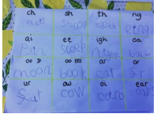

- Play yes or no – your child reads the sentences and decides whether the answer is yes or no
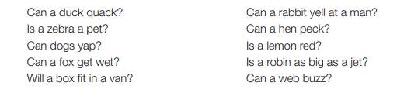

Complete one of the activities from the home learning pack….
- Play what’s in the box –use the word cards and pictures or objects. Put the words in a box, children read the words and find the matching picture or object
- Play Phase 2 Phonopoly
- Read and Roll y z zz qu (your child may need support to read some of the words of the zz page, we have not learnt y as an ee sound and the suffix ed)
- Read the checklist, can you find the pictures on the ispy sheet?
- Play I spy initial sounds
- Complete a wordsearch
- Complete the y z zz qu work book
- j w v x y z zz race game

Suggested words:
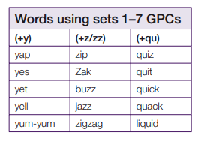

Letters and Sounds Recap Videos

https://wandleenglishhub.org.uk/lettersandsounds/reception

Maths

Recap
Listen to or sing one of these counting songs
- 5 Little Ducks https://www.youtube.com/watch?v=pZw9veQ76fo
- 5 Little Monkeys https://www.youtube.com/watch?v=0j6AZhZFb7A
- 5 Little Speckled Frogs https://www.youtube.com/watch?v=TtX8yVEF0-w
Discuss what happens each time one of the animals go – does the number get bigger or smaller?

Teach
Watch the video taking away on a number line on Tapestry.
Or
Create some number sentences using numbers to 10 e.g.
7-5 =
3-3 =
6-4 =
Ask your child to find the first number in the number sentence on their number line. Then demonstrate ‘jumps’ back to the next number in the sentences. What is the answer?
Ensure your child is doing accurate jumps that land on the next number before doing the next jump back.
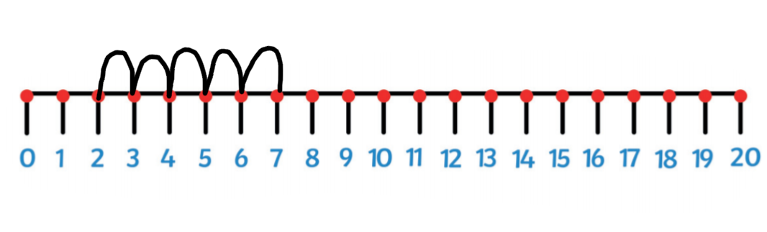
You could create a life size number line so your child can do the jumping.
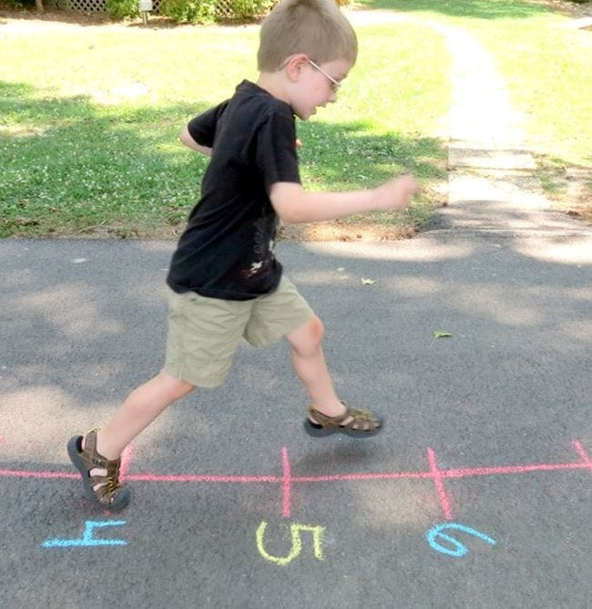

Continue to practise the above activity with different number sentences.
Tuesday 12th May
Phonics

Please use Monday’s planning and select a different activity to complete from the list – if you need further support or ideas please email acorn@st-barnabas.kent.sch.uk

Maths

Recap
Ask your child to show you a number of fingers e.g. 5 – they might show 5 on one hand, challenge them to find a different way of making 5 e.g. 2 fingers on one hand and 3 fingers on the other. Once you have found all the ways of making 5, choose a different number.

Teach
Watch the video ‘Hidden Items 1’ on Tapestry
or
Count out 5 objects (e.g. cars), ask your child to check how many cars you have and that they know how many cars there are.
Then cover the cars with a blanket or scarf. Add 2 more cars under the blanket, make sure your child is watching. Ask them how many cars there are altogether? Encourage them to represent the cars with their fingers – counting 5 (or knowing there are 5), 7, 6.
Repeat with different amounts of objects. Get your child to have a go at add the cars under the blanket and you work out the number sentence.
Key questions – how many cubes did we have to start with? How many cubes did I add? How many cubes will be under the cloth now? How did you work it out?
Wednesday 13th May
Phonics
Please use Monday’s planning and select a different activity to complete from the list – if you need further support or ideas please email acorn@st-barnabas.kent.sch.uk

Maths
Recap
Use the talk about number bonds activity – can you find all the objects that make each number sentence?
Teach
Watch the video ‘Hidden Items 2’ on Tapestry
or
Count out 5 objects (e.g. cars), ask your child to check how many cars you have and that they know how many cars there are.
Then cover the cars with a blanket or scarf. Take away 2 cars from under the blanket, make sure your child is watching. Ask them how many cars there are now? Encourage them to represent the cars with their fingers – counting 5 (or knowing there are 5) and counting back (they may like to use their other hand to represent the two taken away.
Repeat with different amounts of objects. Get your child to have a go at add the cars under the blanket and you work out the number sentence.
Key questions – how many cubes did we have to start with? How many cubes did I take away? How many cubes will be under the cloth now? How did you work it out?

Thursday 14th May
Phonics
Put the flash cards in alphabetical order and sing the alphabet while pointing to the correct letter or listening to https://www.youtube.com/watch?v=jPVbJ-IaHIw
Recap sounds and words taught so far using the flash cards or www.phonicsplay.co.uk (see week 1 home learning plans) – once your child can identify particular sounds, take these out and only recap the ones they have struggled with
Sound pronunciation - https://www.youtube.com/watch?v=IwJx1NSineE
Sounds taught so far - s a t p i n m d g o c k ck e u r h b f ff l ll ss j v w x y z zz qu ch sh th ng ai ee igh oa oo ar or ur ow oi ear air ure air er
Words taught so far - The I to a to go no into put of he she we me be my was you they all

Teach
Tricky word – are
Use your created flashcard and discuss with your child what the ‘tricky’ part of this word is (the whole word, it sounds like it should be spelt ar)
Can your child think of a sentence with the word are in?
Practise and Apply
Choose one of these activities…….
- Practise writing all and other tricky and high frequency words learnt so far
- Hide tricky words around the house for your child to find and read
- Write a sentence with the word all in it
- Listen to ‘The Tricky Word’ songs – Phase 2 https://www.youtube.com/watch?v=TvMyssfAUx0 Phase 3 https://www.youtube.com/watch?v=R087lYrRpgY
- See how many times you can write all in 1 minute
- Complete tricky word search
- Complete Phase 3 tricky word activity book
- Make your own tricky word skittles
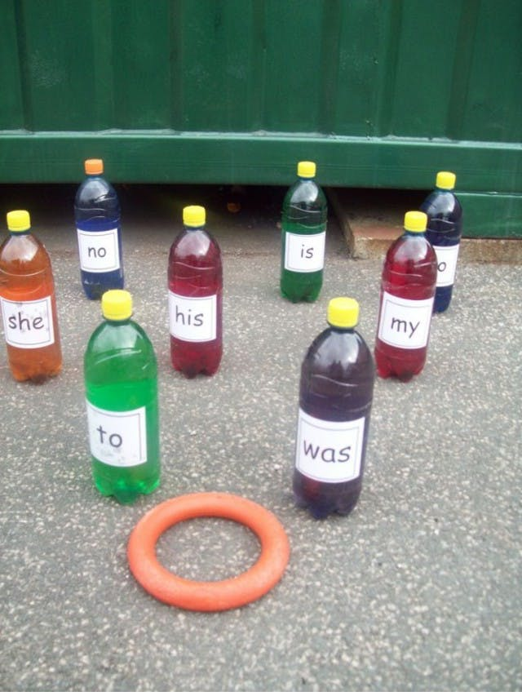

Friday 8th May
Phonics
Recap
Put the flash cards in alphabetical order and sing the alphabet while pointing to the correct letter or listening to https://www.youtube.com/watch?v=jPVbJ-IaHIw
Recap sounds and words taught so far using the flash cards or www.phonicsplay.co.uk (see week 1 home learning plans) – once your child can identify particular sounds, take these out and only recap the ones they have struggled with
You may want to watch the video ‘Phonics with Miss Traviss – Full Phase 3 recap’ on Tapestry (uploaded 4th May).
Sound pronunciation - https://www.youtube.com/watch?v=IwJx1NSineE
Sounds taught so far - s a t p i n m d g o c k ck e u r h b f ff l ll ss j v w x y z zz qu ch sh th ng ai ee igh oa oo ar or ur ow oi ear air ure er
Words taught so far - The I to a to go no into put of he she we me be my was you they all are

Teach
Friday’s phonics lessons are going to be drawing a picture and writing a sentence. The sentence we will write will use at least one of the sounds we have been recapping this week.
Two writing templates have been provided – one has the phoneme frames and one is a single line.
Either use the step-by-step drawing below or watch the video ‘Writing 1’ on Tapestry.
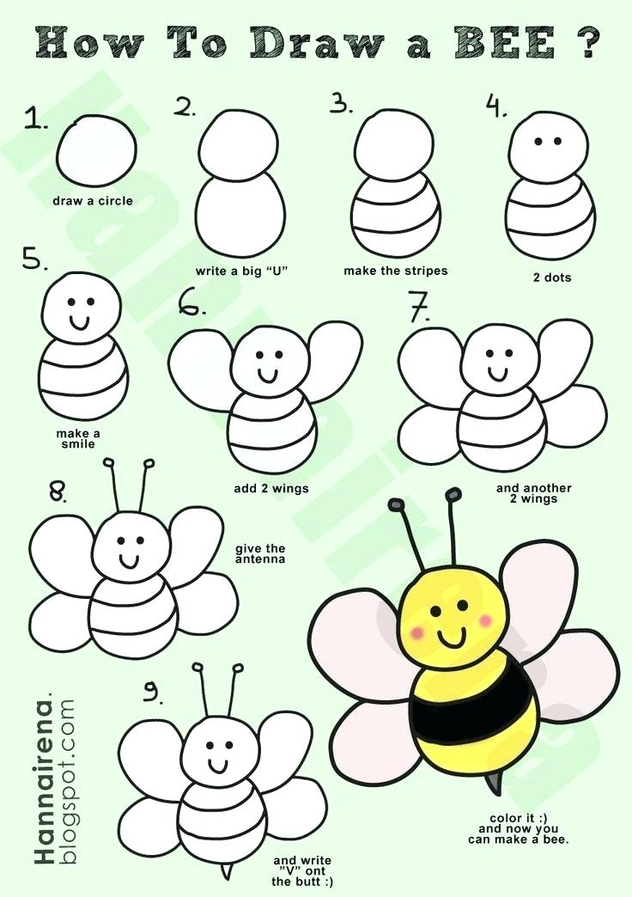

Once you have finished drawing the bee, you have two options
- Use the phoneme frame writing template provided and…
Say the sentence ‘a bee can buzz’. Repeat the sentence several times and get your child to join in.
Once they can confidently say the sentence on their own, ask them to write it down making sure there is one sound in each box.
- Use the line writing template provided and….
Think of your own sentence about the bee. Say the sentence several times and get your child to join in.
Once they can confidently say the sentence on their own, ask them to write it down. Make sure they are hearing all the sounds in the word.

Remind your child to use correct letter formation and encourage them to hear all the sounds in each word. Remember tricky words get written on a line and if you are writing a digraph, both letters go in the same box.

Please refer to the ‘Acorn Class Daily Schedule’ or http://www.st-barnabas.kent.sch.uk/page/?title=Acorn+Class&pid=40 on how to support your child with their writing.

Maths
Recap
Play ‘how many snacks’ - place some fruit (e.g. apples) into two bowls/piles. Can your child find out the total number by counting all of them? Repeat with different amounts and types of fruit.

Teach
Watch the video ‘Simple Maths Story 3’ or ‘Simple Maths Story 4’ on Tapestry. One is addition, one is subtraction. You can choose to do one or both.
Or create your own maths story to tell to your child similar to the one below (you can choose addition or subtraction or both).
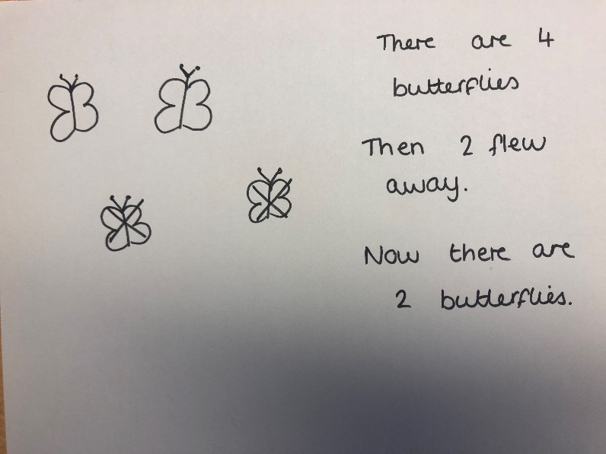
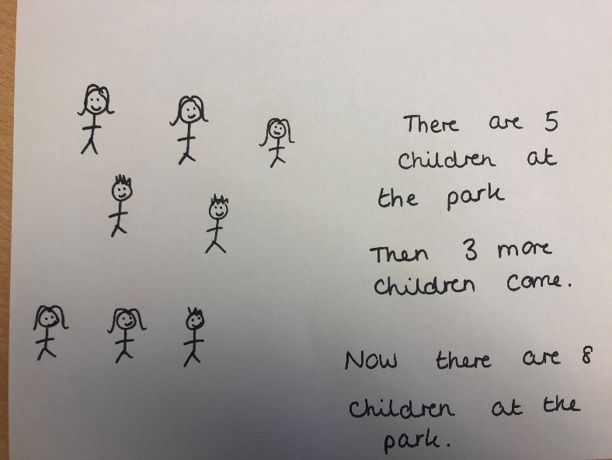
Then your child is to write their own maths story.

Numberblocks episodes to support addition and subtraction:
Blast Off - https://www.bbc.co.uk/iplayer/episode/b08q3zx7/numberblocks-series-2-blast-off
Just Add One - https://www.bbc.co.uk/iplayer/episode/b08q39b4/numberblocks-series-2-just-add-one
Numberblock Castle - https://www.youtube.com/watch?v=PNtcXa1A6fo
The Two Tree - https://www.youtube.com/watch?v=y-2vJad-VAQ
Fluffies - https://www.youtube.com/watch?v=BgJ62VZH6e4
Ten Green Bottles - https://www.youtube.com/watch?v=XGRHV_tAglI
Hide and Seek - https://www.bbc.co.uk/iplayer/episode/b08dmn88/numberblocks-series-1-hide-and-seek
Holes - https://www.bbc.co.uk/iplayer/episode/b08dmjsk/numberblocks-series-1-holes
What’s the Difference? - https://www.youtube.com/watch?v=oKnITCWvnig
Numberblock Rally - https://www.youtube.com/watch?v=L8ZMhan4Flk
Octoblock to the Rescue! - https://www.youtube.com/watch?v=9w5K5PL7fu4
Ten Again - https://www.youtube.com/watch?v=CJ0PQ0VuMpg
Mirror Mirror - https://www.youtube.com/watch?v=OkU0kPbWni8
Three Little Pigs - https://www.bbc.co.uk/iplayer/episode/b08cqtk0/numberblocks-series-1-three-little-pigs

