Watch the learning video and use Mr M’s modelled example to create your own Matilda character description.
In a quiet village, | On a mundane road, | In an ordinary street
Not far from here, | Just around the corner, | Down the road,

T.V dinners | video games | gameshows
mindlessness | television | boredom
rudeness | arguments | dishonesty

gifted | extraordinary | brilliant
kind | thoughtful | quick-witted
talented | smart | clever
wonderful | caring | warm-hearted

She was the sort of girl who…

She was as ______________ as a _____________________

In her hands…
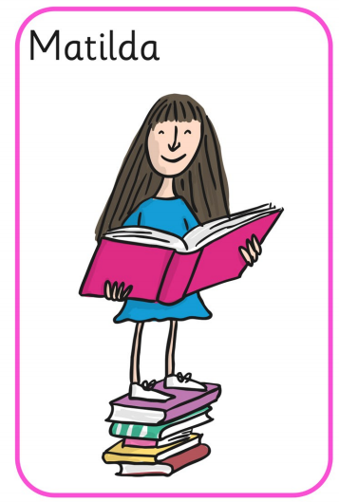
Covering her head…
Covering her shoulders…
On her feet

What a _______________ girls she was!

