Mr Macrae’s Easter Woodland Flower Walk
I told you before Easter that I have been going out once a day to walk my dog in the woods near my house. I
Ifresh have carried on looking at the flowers in the wood. There are some new ones that I didn’t see last month. Others are there but don’t look so healthy.
Try to match the flowers I saw with their names. Ask a grown-up or use the internet for help.
Which ones are new?
Why do you think the daffodil looked like that?
Why do you think plants make flowers?

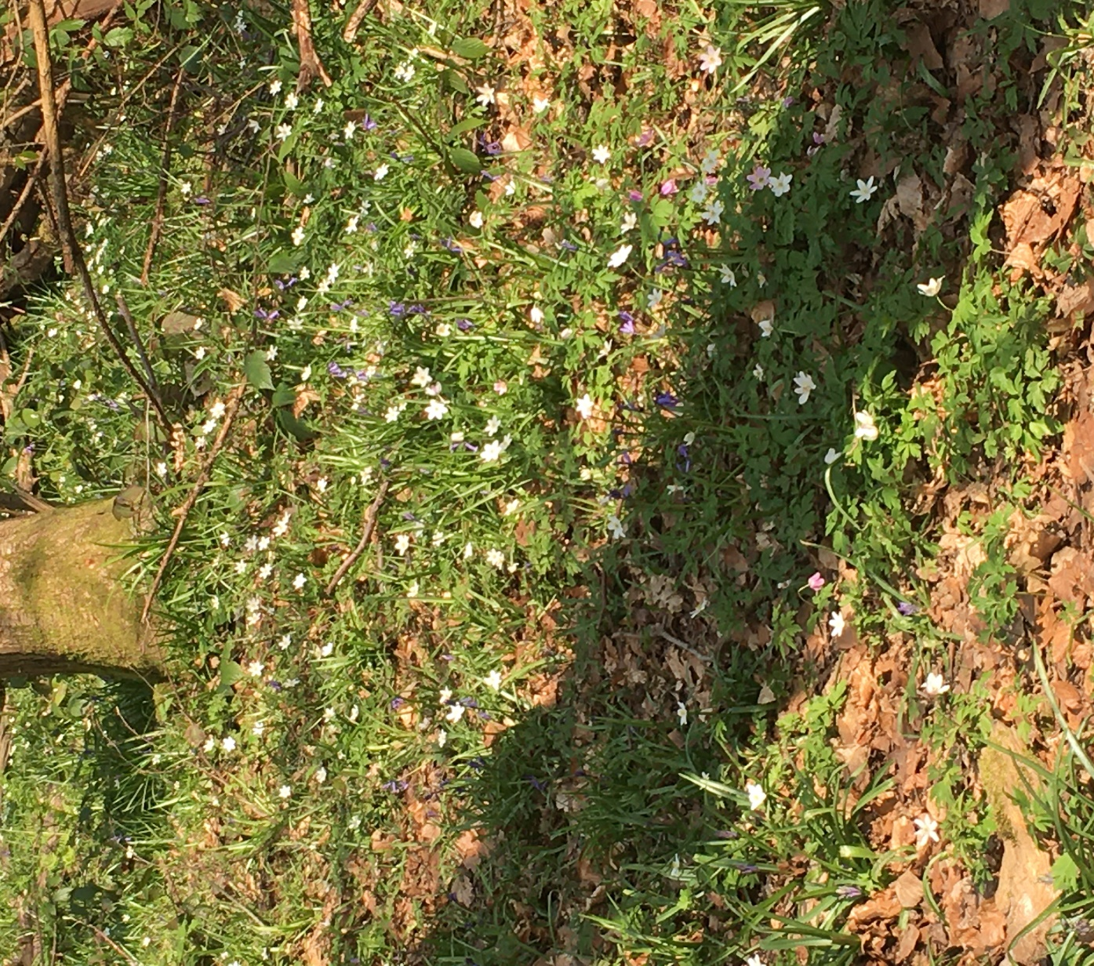

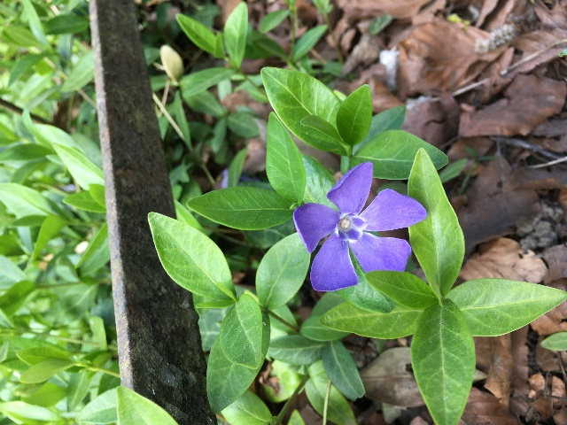
Periwinkle
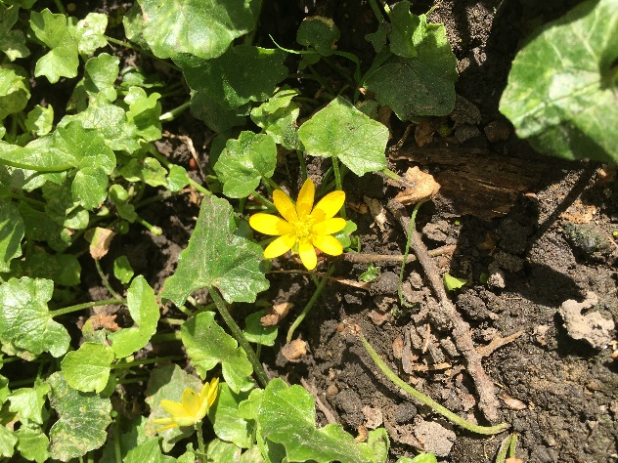
Dandelion
Daffodil
Lesser Celandine
Bluebell
Sweet Violet
Primrose
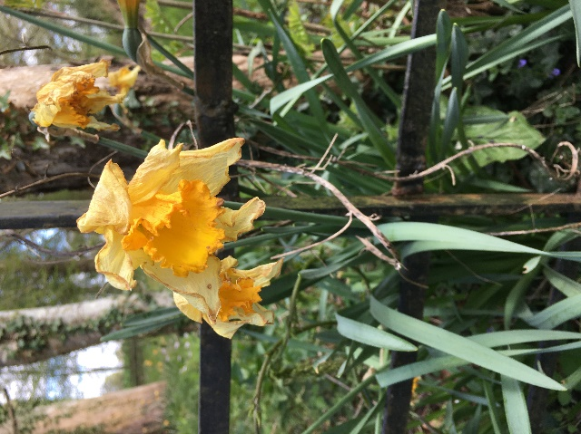
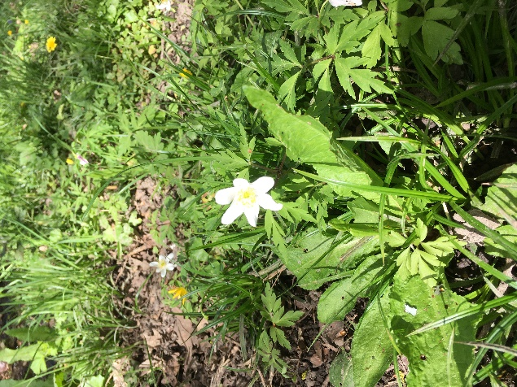
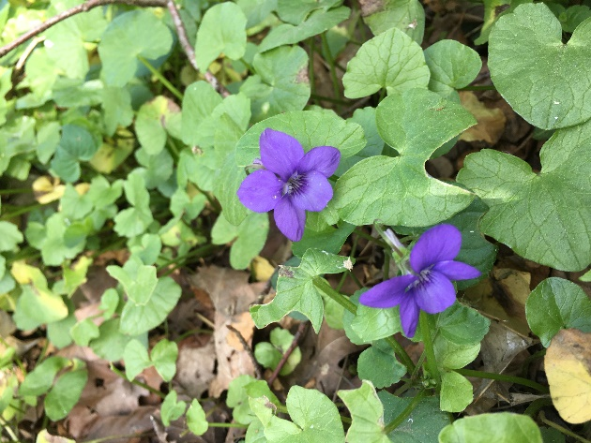
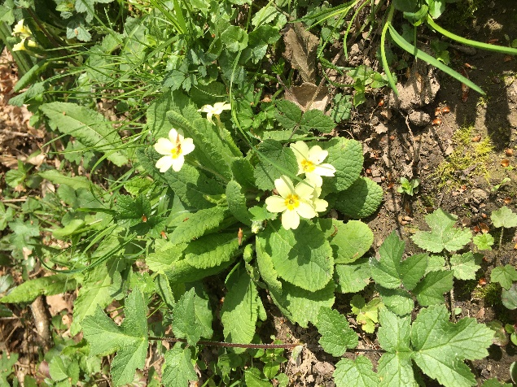
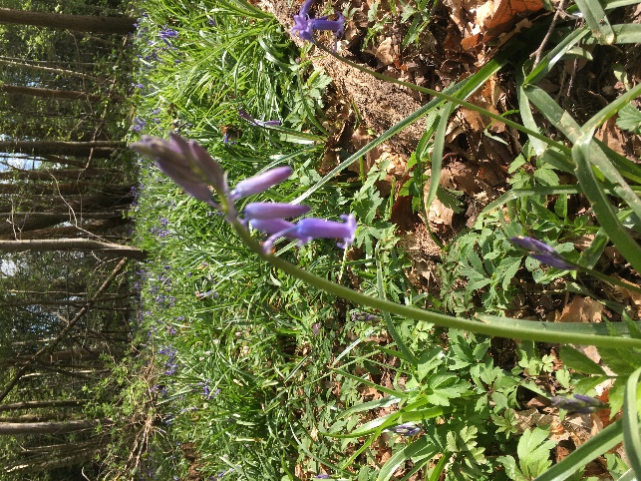
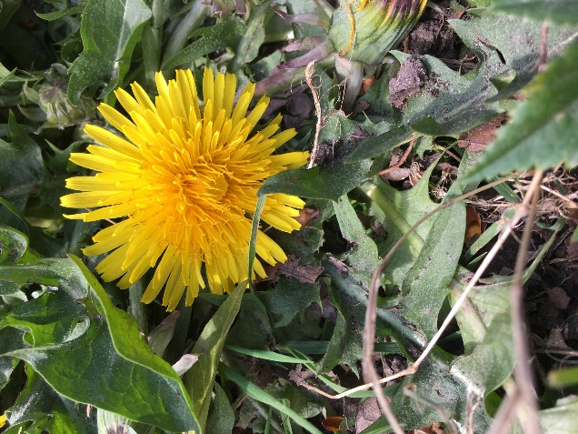
Wood Anemone

