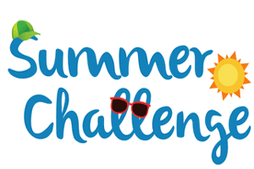
Year 5 Reading

Sign up for this year’s Kent Library Summer Reading Challenge

- It started on Friday 5 June and runs throughout the summer holidays, finishing at the end of September. It is aimed at children aged 4 – 11 and is completely free! The challenge features games, quizzes and downloadable activities to incentivise and encourage children and their families to take part in reading related activities at home. Children can choose their own reading goals, create book reviews, play games and collect virtual rewards. Parents and guardians can register their children online at www.sillysquad.org.uk
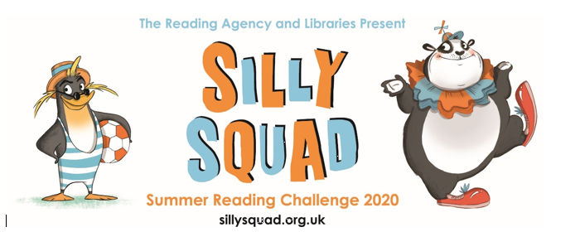

Also, your teachers have set you 10 St Barnabas Reading Challenges to complete over the Summer Holidays.

- Challenge 1: Re-write it
Pick a story that you know really well. Pick a part of the story and rewrite it in the style of the author. How will you make your writing sound like the authors? How will you recreate their choice of vocabulary/sentence structure?

- Challenge 2: Change a Character/Ending
Pick a story that you know really well. Change one of the characters or the ending to turn it in to a new story. Tell your new story to a member of your family.

- Challenge 3: Change the Point of View
Pick a story that you know really well. Retell the story from an alternative perspective. Tell your new story to a member of your family.

- Challenge 4: Get Creative
Get inspired by a book you have read. Create a drawing, sculpture or piece of artwork inspired by your book.

- Challenge 5: Compare It
Find a well-loved story that has recently been turned into a film. Read the book and watch the film. How were they similar? How were they different? Which did you prefer? Why?

- Challenge 6: Write to a Character
Pick a favourite character form a familiar story. Write to them. You could write a formal letter, a note to pass under their door, an email or even a text/WhatsApp message. It is up to you. Imagine that they received you message. What do you think they would write back?

- Challenge 7: Turn it into a Comic
Pick a story that you know really well. Draw pictures and use speech bubbled and captions to turn it into a comic strip.

- Challenge 8: Review It
Write a book review of one of your favourite books. Who are the characters? What were the main events? What genre was it? How does it compare to other books of this genre? How does it compare to other books by this author? Who would enjoy this book and why? What rating would you give it?

- Challenge 9: Take it Outside
Pick a book that you love. Pick a setting from the book and take it to a real life location to read. For example, take Swallows and Amazons and read it on the beach.

- Challenge 10: Make a Book Nook
Make a special place in your house to read. Make it a cosy and snug space place to read independently.

If you manage to complete any of these challenges and would like to share them with us, send your pictures or work in to the Summer Challenge email address:
summerchallenge@st-barnabas.kent.sch.uk

