Reasoning with Multiplication

1)

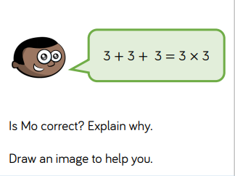

2)

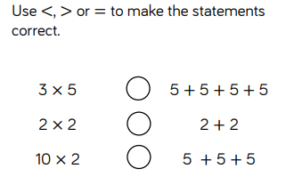

3)

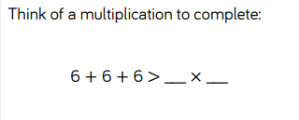

4)

C:\Users\cmackinnon\AppData\Local\Temp\b53c6919-e300-4166-a8cd-a931632da052.png

5)

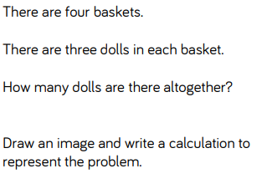

6)



