Home Learning Plans
Beech Class
Week Beginning: Monday 1st June
Reading:
- The National Literacy Trust has created a selection of materials designed to support young readers at home.
https://literacytrust.org.uk/family-zone/5-8/young-readers-home/
Here are three of the activities that you might light to try:
-Word Hunt
-Make a Book Cover
-Create a Creature

- Visit the Oxford Owl website. https://www.oxfordowl.co.uk/ Click on the My Class Login section
Use the following details to log in to the newly created beech class section.
Username: beechclass101
Password: pupil
Click on the ‘My Bookshelf’ section and select reading books that are right for you. Use the ‘Age Groups’ section to help narrow down the search.

- When completing guided or supported reading of an age appropriate text, focus on application/synthesis questioning. Use the application/synthesis section of this questioning tool to generate questions that challenge your child to apply their understanding and synthesise what has happened in the story so far.
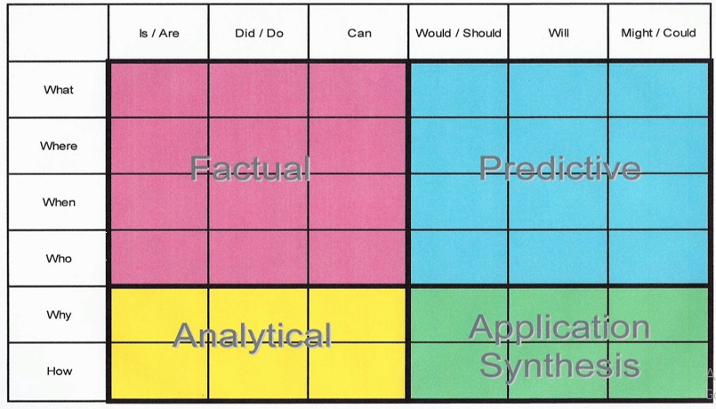
- For example:
- -Why should they do that?
- -Why might they not want to do that?
- -How might the character feel here?

- If you are looking for more interesting ideas and resources relating to children’s books, why not explore the children’s section of the British Library Website. https://www.bl.uk/childrens-books

Spelling:
- Log on to Purple Mash and complete the spelling ‘2Dos’ which have been selected for you.

Writing:
This week we are going to continue to use a ‘Talk for Writing’ resource to inspire some drawing and writing activities. This week we will focus on the pages 13 to 18
https://www.talk4writing.co.uk/wp-content/uploads/2020/04/Y2-Unit.pdf
- Read page 13. Write and explain your own examples of apostrophes of possession.
- Read pages 14 and 15. Share your thoughts and feelings about the poem by Kit Wright. Listen to Kit reading the poem: https://www.bbc.co.uk/bitesize/clips/zkpmhyc
- Read page 16 and 17. Make a magic box. List all the possible items that you might put into your magical box. Arrange 9 of your ideas into 3 verses.
- Read page 18. Write about what your box is made from.
- Put all of your ideas together to create your own magic box poem.

Topic: At Home and Abroad
This week we are going to explore the climate of the two locations that we are learning about.
- Look at the pictures on the ‘Vietnam Climate Pictures’ document. What are your initial thoughts about the climate of Vietnam? Use the ‘Climate Word and Phrase Bank’ to help share your ideas.
- Watch the learning video about the climate in Vietnam.
- Share what you have found out about the climate of Vietnam with a member of your family.
- How does the climate of Vietnam compare to the climate of Tunbridge Wells? Use temperature and rainfall maps to help make your comparisons.

Maths:
This week we are going to cement and extend our understanding of multiplication.
- Watch the multiplication learning video.
- Use the skills that you have learned in this video to complete the ‘Multiplication Problems Counting’ activity.
- Use the skills that you have learned in this video to complete the ‘Multiplication Problems Sorting’ activity.
Extension: If you are looking for an extra challenge, complete the ‘Multiplication Efficient Method’ activity.

- Log on to MyMaths- https://www.mymaths.co.uk/ Complete the following MyMaths activities
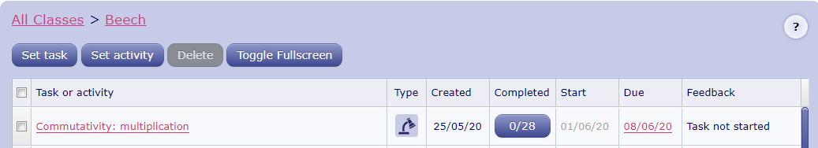
- Complete the ‘Multiplication using arrays’ Maths With Parents activity- class code: 233033
- Complete the ‘Multiplication on a number line’ Maths With Parents activity- class code: 233033

Number Fluency:
- If you haven’t done so already, Watch the ‘Multiplication and Division Fact Families’ learning video:
- Log on to Times Tables Rockstars and start practising your multiplication and division facts for the 1 2, 5 and 10 times tables. Use your learning from the ‘fact family’ activities to help you work out the division facts.
IMPORTANT: If you feel that your child has mastered these times tables and requires a new challenge, please contact us via the class email address: beech@st-barnabas.kent.sch.uk so we can allocate a new level of challenge for your child.

Wider Curriculum
- Pick activities of your choice from the wider curriculum matrix.

