[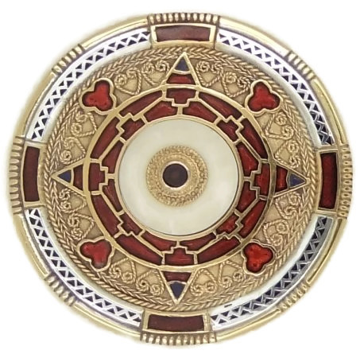](https://www.google.co.uk/url?sa=i&rct=j&q=&esrc=s&source=images&cd=&cad=rja&uact=8&ved=2ahUKEwjZrNLTl-naAhUBaRQKHSSBAq0QjRx6BAgBEAU&url=http%3A%2F%2Fwww.ganderwick.com%2Fourshop%2Fprod_2226908-Kentish-Style-Anglo-Saxon-Brooch.html&psig=AOvVaw0BaeihA0vd8uTGiELxY7U4&ust=1525424608620294)[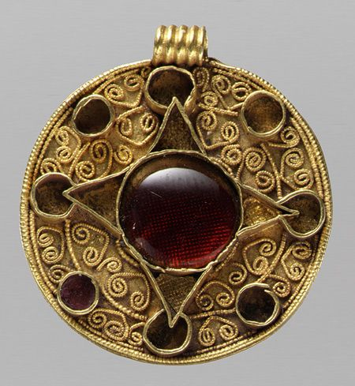](https://www.google.co.uk/url?sa=i&rct=j&q=&esrc=s&source=images&cd=&cad=rja&uact=8&ved=2ahUKEwiK8N3sl-naAhWE7xQKHYR0BuwQjRx6BAgBEAU&url=https%3A%2F%2Foldenglishwordhord.com%2Ftag%2Fanglo-saxon%2F&psig=AOvVaw0BaeihA0vd8uTGiELxY7U4&ust=1525424608620294)[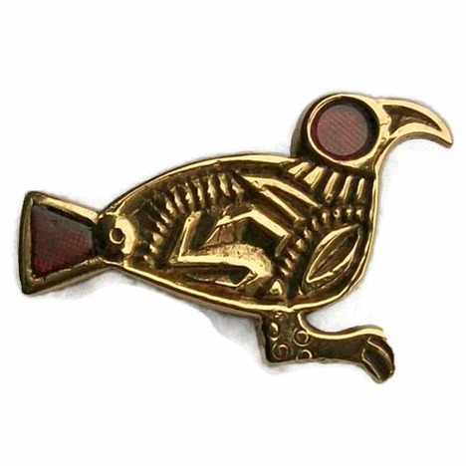](https://www.google.co.uk/url?sa=i&rct=j&q=&esrc=s&source=images&cd=&cad=rja&uact=8&ved=2ahUKEwit-8n_l-naAhXCRhQKHcsQDNkQjRx6BAgBEAU&url=http%3A%2F%2Fwww.ganderwick.com%2Fourshop%2Fprod_2432548-Finglesham-Bird-Brooch.html&psig=AOvVaw0BaeihA0vd8uTGiELxY7U4&ust=1525424608620294)[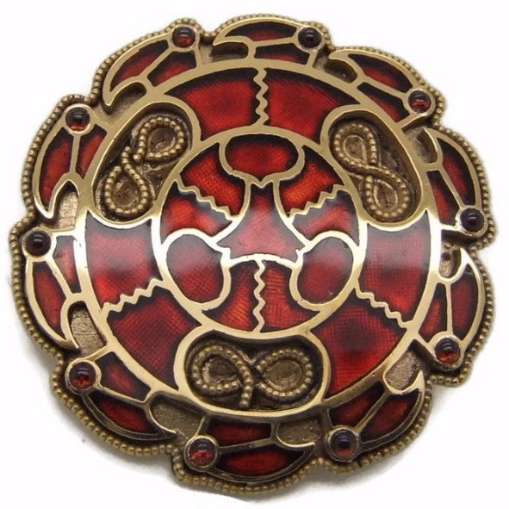](https://www.google.co.uk/url?sa=i&rct=j&q=&esrc=s&source=images&cd=&cad=rja&uact=8&ved=2ahUKEwig4fGTmOnaAhVDWhQKHRogCgoQjRx6BAgBEAU&url=http%3A%2F%2Fwww.ganderwick.com%2Fourshop%2Fprod_2234604-Merovingian-Disc-Brooch.html&psig=AOvVaw0BaeihA0vd8uTGiELxY7U4&ust=1525424608620294)[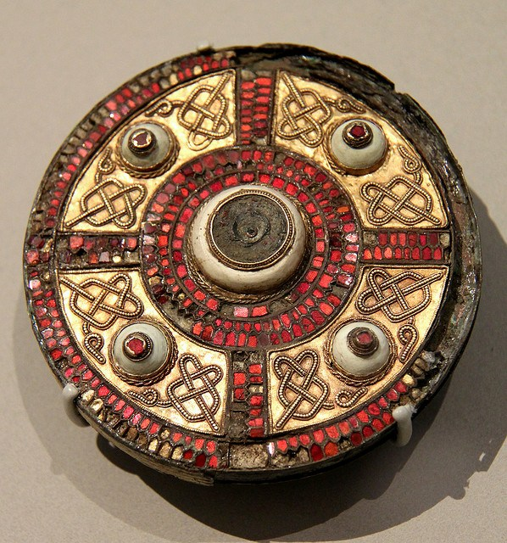](https://www.google.co.uk/url?sa=i&rct=j&q=&esrc=s&source=images&cd=&cad=rja&uact=8&ved=2ahUKEwj1uZDomOnaAhXEShQKHT9NDfYQjRx6BAgBEAU&url=http%3A%2F%2Fwww.medievalists.net%2F2015%2F08%2Fbroaching-the-subject-the-geometry-of-anglo-saxon-composite-brooches%2F&psig=AOvVaw0BaeihA0vd8uTGiELxY7U4&ust=1525424608620294)[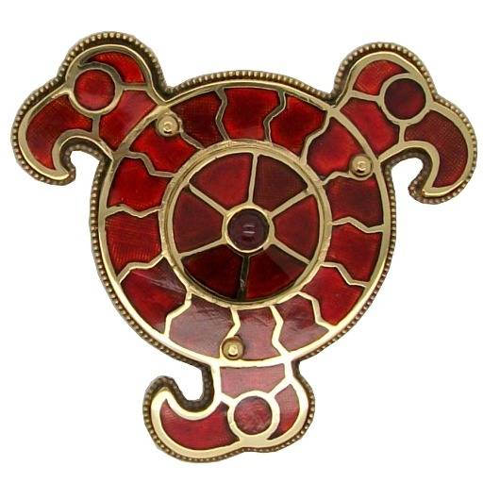](https://www.google.co.uk/url?sa=i&rct=j&q=&esrc=s&source=images&cd=&cad=rja&uact=8&ved=2ahUKEwiN94OimOnaAhVCvhQKHSkvAAcQjRx6BAgBEAU&url=http%3A%2F%2Fwww.ganderwick.com%2Fourshop%2Fprod_2487730-Gepid-Brooch.html&psig=AOvVaw0BaeihA0vd8uTGiELxY7U4&ust=1525424608620294)