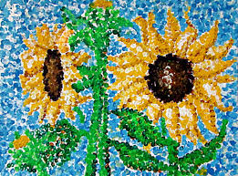

**Sunflower picture using Pointillism**