Watch the multiplication learning video. Use your sorting skillsto solve these multiplication problems.

|  |  |
| --- | --- |
|  |  |
|  | |
|  | C:\Users\cmackinnon\AppData\Local\Temp\6d574c84-4f9b-4dd7-8de9-edba1d85ab27.png |
|  | |

|  |  |  |
| --- | --- | --- |
| C:\Users\cmackinnon\AppData\Local\Temp\0583966c-d0ab-4dc9-8563-23e6e463f279.png | | C:\Users\cmackinnon\AppData\Local\Temp\bf9b5481-129a-4b42-a053-470eaefa3f76.png |
| C:\Users\cmackinnon\AppData\Local\Temp\98669381-c9a9-4fa1-a77a-61068b1842ea.png | C:\Users\cmackinnon\AppData\Local\Temp\e51b8610-6ad6-403b-a59c-610904f722c0.png | |

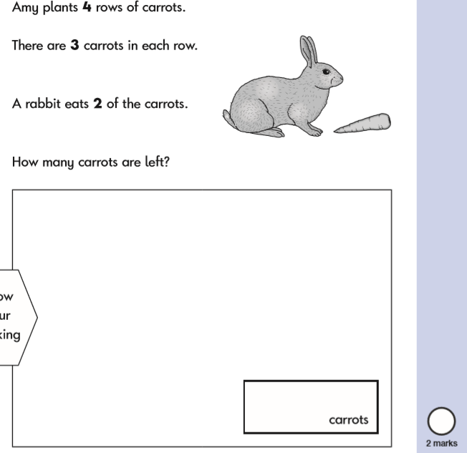

Can you draw a picture to help you solve this problem?