Home Learning Plans
Chestnut Class

Week Beginning: 18th May
Dear Chestnut parents/carers and children,
Your core learning for the week is set out in this letter.
Reading: Read Chapters 23, 24 and 25 of Varjak Paw, which are provided for you. There are also some questions to answer. See if you can follow the pattern we have adopted of reading and re-reading before answering the questions. I hope you are all enjoying the twists and turns of this book. I am so desperate to read ahead, but I want to have a shared experience with you and uncover it week by week!
Please also make sure you are carrying out additional reading each day. You could use the grid below to explain what you are reading to an adult. Challenge yourself to ask questions based on each area of the chart. For example, you could ask a ‘why?’ question from the left side, or combine it with a ‘might’ question from the top section to create a ‘why might? ‘ question.
Oxford Owls This website provides access to free reading material. You will need to use the log on: chestnut101 and the password: pupil
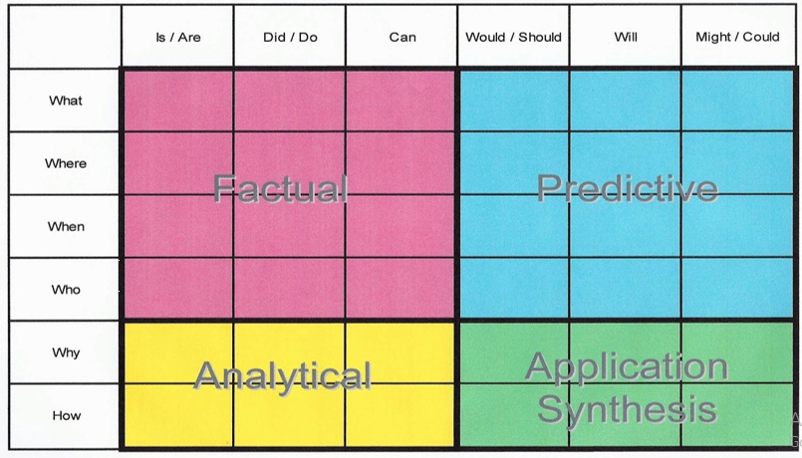

You have a grammar activity relating to the ‘have/of’ and ‘these/those/them’.
You have 4 sets of spellings quizzes to revise the work you have covered so far while working at home.
This week’s writing task is to create a poem dedicated to your favourite food. It may even be something you can’t get at the moment that you are craving! This type of poem in praise of something is called an ode. I have provided you with a definition, some examples and a list of tasks to do before you create your own. Please feel free to send finished poems to me so I can enjoy them - you know how much I love food!!
chestnut@st-barnabas.kent.sch.uk

Maths:
This is our final week on fractions!
I have provided worksheets that will help further develop your understanding of fractions. Challenge yourself to work through as many of the levels as you can! I recommend tackling them in the following order:
Fractions of a quantity FLUENCY
Fractions of a quantity REASONING AND PROBLEM SOLVING
Calculate quantities FLUENCY
Calculate quantities REASONING AND PROBLEM SOLVING
Fluency: There are 3 fractions tasks set on Purple Mash. You can also use this platform to practise times tables fluency.
I have also set 2 fractions activities on MyMaths

Wider Curriculum -
You have a set of Science Week activities which can also be completed over the half term. Enjoy!
I hope you are all well.
Take care,
Mrs Barter

