Beech Home Work: Term 1 Week 5 (Due in Monday 12th October)
This week we would like you to write some descriptive sentences about the castle in Aaron Becker’s Journey.
Here is a picture to help inspire you.
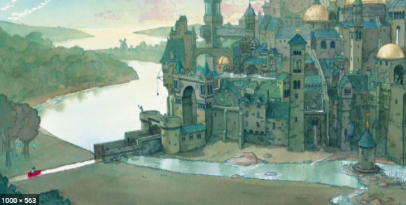
Last week in class, we shared all our ideas to create this help sheet. Please use the attached help sheet to pick a prepositional phrase, a verb phrase, adjectives and a noun phrase to create a descriptive sentence. e.g.

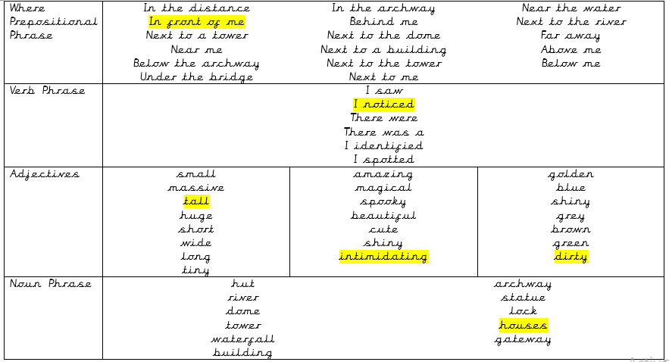
In front of me, I noticed tall, intimidating, dirty houses.

We would like at least 3 fantastic descriptive sentences please! You can write them in your home learning book or send them into the class email address.
Extension: Can you think of a way of showing how the girl felt as she sailed towards the castle?

