Home Learning Plans
Chestnut Class

Week Beginning: 13th July
Dear Chestnut parents/carers and children,
Your core learning for the week is set out in this letter.
Reading: You now have your own copy of The Outlaw Varjak Paw, so please read chapters 5 and 6 in order to answer the questions I have set. Remember that in class we always read a chapter several times before we tackle the questions.
I will be doing another googlemeet story session. You will be sent the access details for this session by parentpay.
Please also make sure you are carrying out additional reading each day. You could use the grid below to explain what you are reading to an adult. Challenge yourself to ask questions based on each area of the chart. For example, you could ask a ‘where?’ question from the left side, or combine it with a ‘should’ question from the top section to create a ‘where should ‘ question.
Oxford Owls This website provides access to free reading material. You will need to use the log on: chestnut101 and the password: pupil
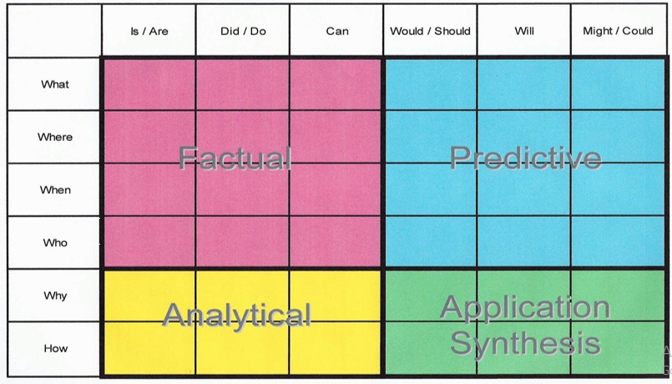

You have a grammar activity on consolidating noun types. I have included an information poster to remind you of the different noun types.
You have a spelling quiz on Purple Mash and a ‘look, say, cover, write’ sheet to practise with.
Your task this week is based on chapter 6 of The Outlaw Varjak Paw. You get introduced to Mrs Moggs and some of the cats who live with her near the harbour. I would like you to create 4 characters who might live with her. You can draw these cats and I would like a description of their appearance and character. Please challenge yourself to use some exciting adjectives and some similes. Think about where they have come from and what their lives were like before they joined Mrs Moggs’ gang.
chestnut@st-barnabas.kent.sch.uk
Maths:
As we are at the end of the school year, I have given you two consolidation packs for multiplication and division.
VARIED FLUENCY WORK
REASONING AND PROBLEM SOLVING
Maths fluency: You have 2 MyMaths activities to refresh your times tables knowledge. You also have Purple Mash multiplication and division tasks.
Wider Curriculum -
Please take this opportunity to complete any outstanding work from previous wider curriculum matrices. You can continue to do this over the summer holidays if you wish, and also look out for the Summer Challenge activities which will appear on the school website from 22nd July!
I hope you are all well.
Take care,
Mrs Barter

