Home Learning Plans
Lilac Class
Week Beginning: Monday 20th April
Reading:
- Carry on with your daily independent reading.
- I have typed out Chapters 18 and 19 of Street Child by Berlie Doherty for your child to read. To recap: During your child’s reading sessions the model is that you initially read one chapter, one session and the next, the other. Each session lasts approximately 30 minutes. Remember to occasionally stop and ask your child what they think the meaning of a tricky word could be, looking at the context of the sentence. The next two sessions will involve them re-reading the two chapters. During the final session your child needs to complete the reading comprehension questions that I have attached and then go over the answers with you. Most of the questions are open ended and there may be several answers to the questions. The purpose of the exercise is to develop reading comprehension skills and to discuss the text – that is why I have not given you an answer sheet.
- Visit the Oxford Owl website. https://www.oxfordowl.co.uk/ Click on the My Class Login section
Use the following details to log in to the newly created Lilac Class section.
Username: lilac101
Password: pupil
Click on the ‘My Bookshelf’ section and select reading books that are right for you. Use the ‘Age Groups’ section to help narrow down the search.
- When completing guided or supported reading of an age appropriate text, focus on analytical questioning. Use the analytical section of this questioning tool to generate questions that challenge your child to analyse what has happened in the story.
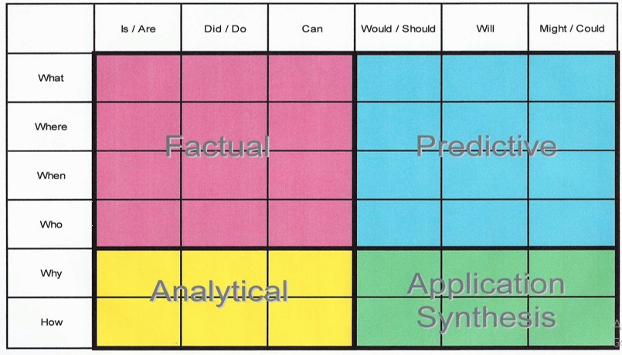
For example:
-Why did they do that?
-How can you tell that…?

Spelling, Punctuation and Grammar:
- I have set activities about the use of ‘s, direct and indirect speech and colons and semi-colons on SpaG.com as a consolidating exercise of work previously covered. Please ensure that your child reads the questions carefully and does not rush through the activities.
- As a ‘2Do’ on Purple Mash I have set an activity entitled ‘Word Splits’. Your child needs to sort a selection of words into nouns, adjectives, verbs and adverbs.
- As a ‘2Do’ on Purple Mash I have set a spelling quiz about words ending in ‘cious’. This is revision of a previous spelling pattern we have learnt.
Writing:

- I would like your child to write a Sea Poem. LO: To draft a poem about the sea using personification. Personification is when human characteristics are given to something that is not human. When writing the poem, the sea needs to have human characteristics. It could, for example, be male of female with hair, a crown, a beard, a dress, a cloak, arms and legs, it can roar, whisper. I have attached two sea poems that show examples of personification. I would also like your child to use some examples of onomatopoeia (when a word describes a sound and mimics the sound it makes, for example, ‘bang’, ‘crash’, ‘thud’ ‘whoosh’). Ensure that lots of adjectives and adverbs are used and add the odd metaphor and/or simile. Emphasise to your child that they are not writing a story and that a poem is structured very differently. Each new idea should begin on a new line with a capital letter and your child could create a repeated refrain or phrase (as used in the first poem, ‘Ocean of Mystery’). Your child could also set out their poem to form a pattern (as shown in the second poem, ‘Listen to the Sea’). Before starting the poem and as stimulus for their writing, I have attached some different photographs of the sea. Discuss the colours, patterns and movement of the sea. For the final poetry writing stage, ask your child to read through their poem. How can they make it even better? What could they add to improve it? Once you have discussed this, the next task is to level up the poem and decorate it LO: To level up a poem about the sea using personification.
- Write a book review about a book that you have read recently. I have attached another book review worksheet for your child to use for this task. It might be about a book they have read from the Oxford Owl selection.

Maths: This week we are learning about equivalent fractions.

- Watch my learning video LO: To recognise equivalent fractions.
- Please complete attached worksheets on equivalent fractions. I have included the answers! You do not need to print out the sheets. Just write out the calculations in your exercise book.
- Work through the Classroom Secrets worksheets. They become more challenging as you work through the pages of questions. The third page is the most challenging. You can copy out the questions and complete your calculations in your exercise book. Again, there is no need to print them out. The answers are attached!
- Complete your Maths with Parents equivalent fractions activity if you have not completed it yet. Class Code 483721. Ensure that the multiplying 4 digits by 2 digits is also completed. I have also set MyMaths equivalent fractions tasks. Please see attached Homework sheet for details.
- Number Fluency: As a ‘2Dos’ on Purple Mash I have set you an activity entitled ‘Factoroids’. Your child can choose what challenge they would like to do!

- Wider Curriculum: Pick activities from the Wider Curriculum Learning Matrix.

- I have also attached my regular Homework sheet that your child would normally receive every Thursday.

