Jack’s Beetle
Jack ran in the park.
He ran after a beetle.
The little beetle hid in the grass.
Jack looked and looked.
He could not find it.
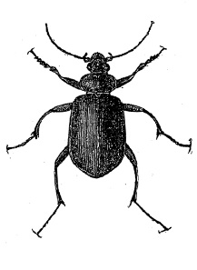
1. Where did Jack run?
——————————————————————-
2. What did Jack do?
——————————————————————-
3. Was the beetle big or little?
——————————————————————
4. Where did the beetle hide?
——————————————————————
5. Did Jack find the beetle?
——————————————————————

