Months and Years
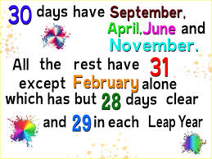
Have a go learning this rhyme. It helps to remember how many days each month has.

Now, Have a go at these questions. Your calendar can help.
What month comes after May? _________________________
What month comes before August? ______________________
What month comes after September? ____________________
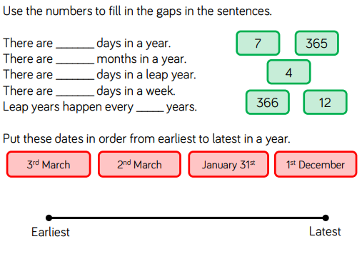
What month comes before January? _____________________

