Instructions: Use the ‘Comparing Shapes Help Sheet’ to help you describe the similarities and differences between the shapes in the pictures. The first one has been done for you.
Supported Independent Group
L.O. To compare and contrast 2D shapes

Shapes | Similarities | Differences
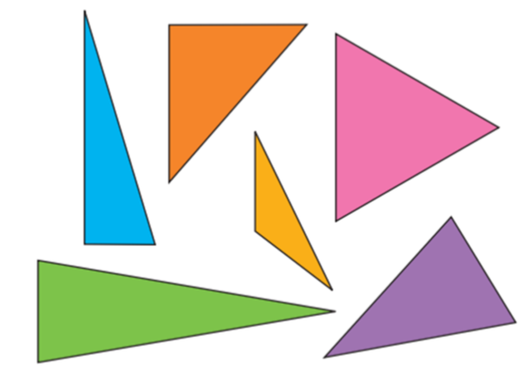 | They all have 3 sides.  They all have straight sides.  They are all called triangles.  They are all 2D shapes.  They all have 3 vertices. | They are different colours.  Their sides are different lengths.  Some are regular and some are irregular.
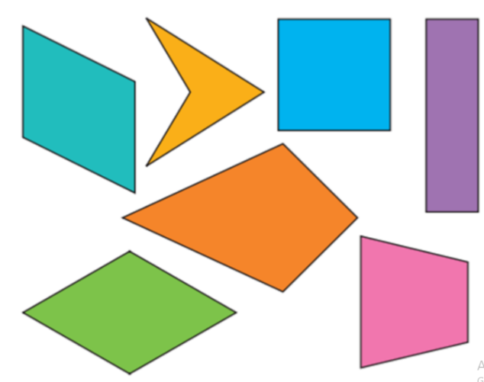 | _________________________________  _________________________________  _________________________________  _________________________________  _________________________________  _________________________________  _________________________________ | _________________________________  _________________________________  _________________________________  _________________________________  _________________________________  _________________________________  _________________________________

Shapes | Similarities | Differences
                            

