Use your knowledge of scales to interpret these block diagrams showing the things that Mr M sold in his new stationary shop.

How many books were sold in the shop?
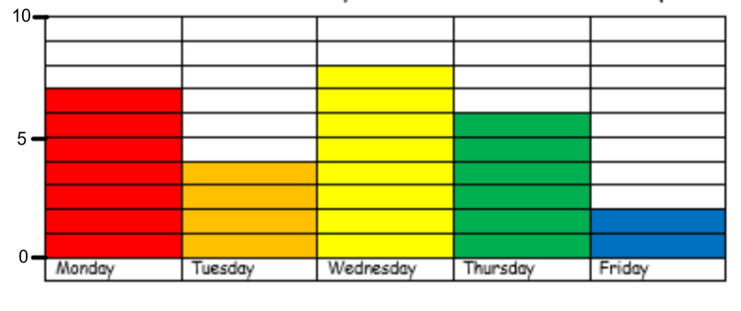
How many books were sold on Tuesday? ____________________
On which day were the most books sold? ___________________

How many pencils were sold in the shop?
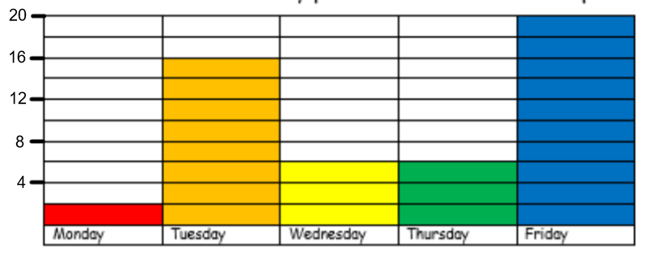
How many pencils were sold on Friday? ____________________
On which day were the fewest sold? ___________________

How many rubbers were sold in the shop?
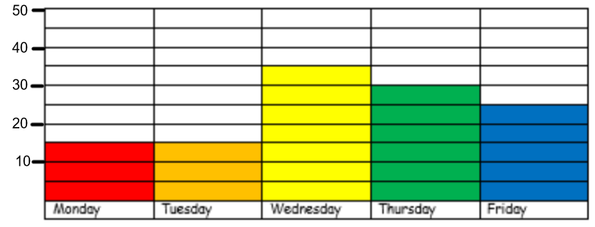
How many rubbers were sold on Thursday? ___________________
How many rubbers were sold on Monday? ____________________

How many pieces of paper were sold in the shop?
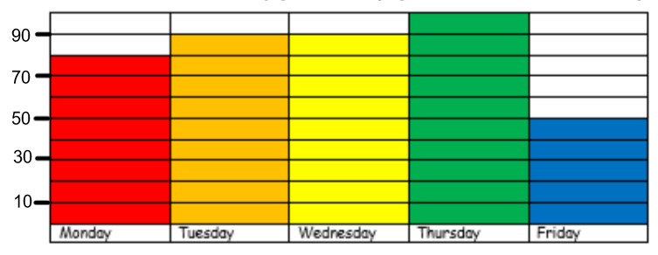
How many pieces of paper were sold on Tuesday? ______________
On which days were the same number of pieces of paper sold? ___________________________________________________

