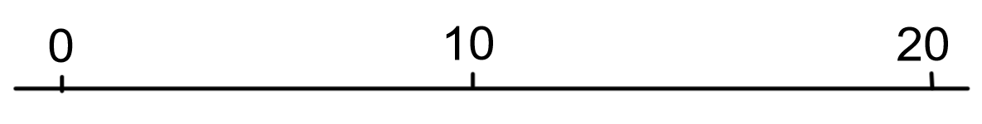
10 – 8 =
10 – 4 =
10 -7 =
10 – 5 =

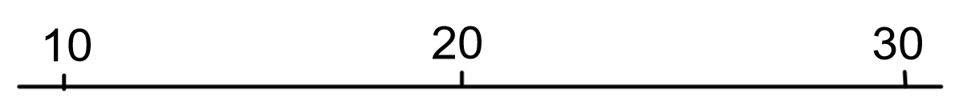
20 – 6 =
20 – 9 =
20 -3 =
20 – 2 =

30 – 7 =
30 – 8 =
30 -6 =
30 – 1 =

40 – 5 =
40 – 9 =
40 -6 =
40 – 3 =

50 – 6 =
50 – 8 =
50 -7 =
50 – 4 =

Now set yourself some subtraction problems. Use a multiple of 10 as the minuend and a single digit as a subtrahend.

