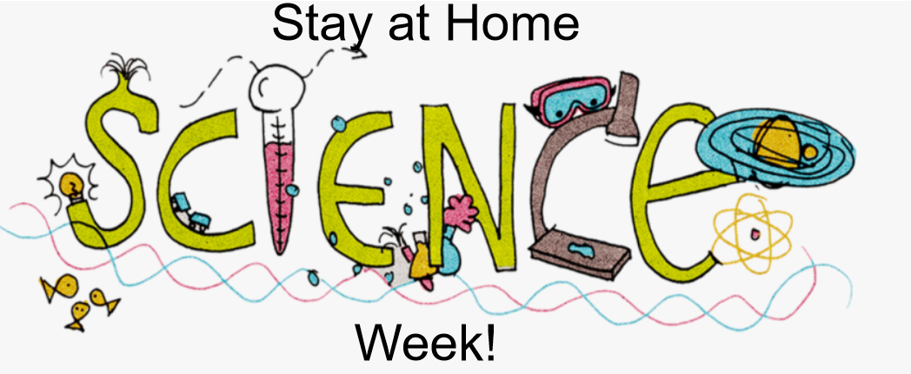

How Do I Take Part?
Step 1- Find the plans and resources on the school website. (You have already done this!)
Step 2: Select an activity from the list below.
Step 3- Follow the link, watch the video, and/or read the instructions.
Step 4- Complete the scientific activity with the support and guidance of an adult.
Step 5- Record how many ‘Science Week Electrons’ you have earned.

2 Electron Activities:
Each time you complete one of these activities, you can add 2 ‘Science Week Electrons’ to your total. Instructions for each activity can be found using the following link or in the documents attached to the bottom of this page.
https://www.stem.org.uk/resources/elibrary/resource/25416/do-try-home#&gid=undefined&pid=2
- Alka-Seltzer Rocket

- Magic Balloon

- The Forceful Comb

- Straw gun

- Making a Moving Foil Boat

3 Electron Activities:
Each time you complete one of these activities, you can add 3 ‘Science Week Electrons’ to your total. A video and instructions for each activity can be found by following the relevant links. Instructions for each activity are attached to the bottom of this page.
- Rubber Band Cannons
https://www.rigb.org/families/experimental/rubber-band-cannons

- Musical Coat Hangers
https://www.rigb.org/families/experimental/musical-coat-hangers

- Homemade Parachutes
https://www.rigb.org/families/experimental/homemade-parachutes

- Fizzy Cubes
https://www.rigb.org/families/experimental/fizzy-cubes

4 Electron Activities:
Each time you complete one of the BIG QUESTIONS, you can add 4 ‘Science Week Electrons’ to your total.
- BIG Question (A) – Can light pass through materials? How much light comes through each one?

- BIG Question (B) – What happens if you mix salt with water and try to freeze it? What about sugar? Baking soda?

- BIG Question (C) – Can you use a drinking straw to make a musical instrument? What different sounds can you make? How are these sounds made?

5 Electron Activities:
Watch the video of Mr M modelling how to complete a ‘Fair Test’.
If you can complete your own fair test, you can add 5 ‘Science Week Electrons’ to your total. Here are some possible questions to investigate:
- Does the height at which you drop the ball affect how high it bounces?

- Does the size of ball affect how high it bounces?

- Does the material the ball is made from affect how high it bounces?

- Does the surface it bounces on affect how high a ball bounces?

How do I get my certificate?
Don’t forget to count up how many ‘Science Week Electrons’ you have earned in total. Send this information to Mr Mackinnon: beech@st-barnabas.kent.sch.uk and we will organise your Stay at Home Science Week Certificate.
The closing date for entries is Tuesday 2nd June.

EXTRA CHALLENGE:
How do you think Mr M is going to use the number of electrons you have earned to work out which certificate you get? Can you predict which certificate you will receive before it even arrives.
CLUE: Mr Mackinnon is going to use a tool called the Periodic Table to help him.

