Now Edit and Publish your Story!

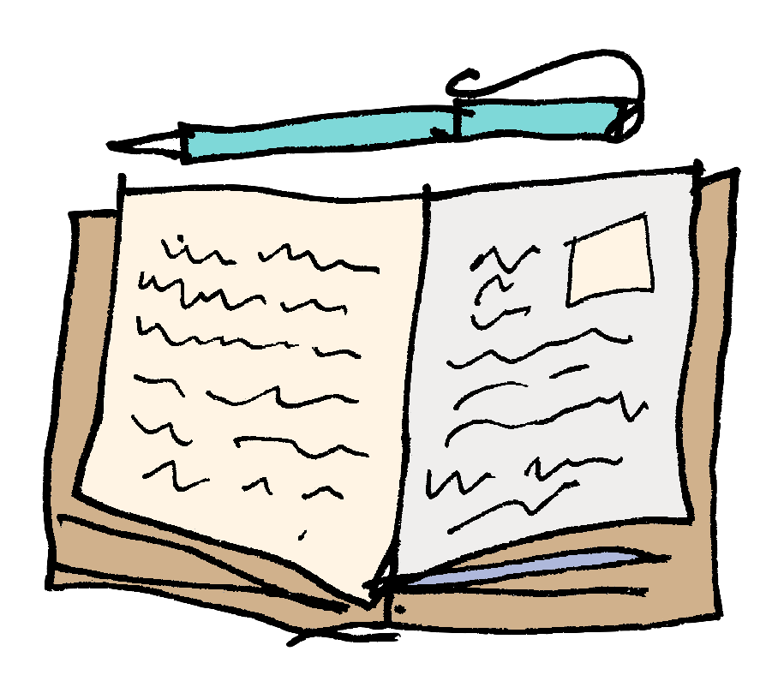
  - Read your work through and check that it flows and makes sense
  - Remember to check the spelling and punctuation and illustrate your text with pictures or drawings.

Well done! Now that you have a new story, why not publish it? Below are some simple instructions for making a mini book from a piece of A4 paper.

If you have access to the Internet, type this into Google:
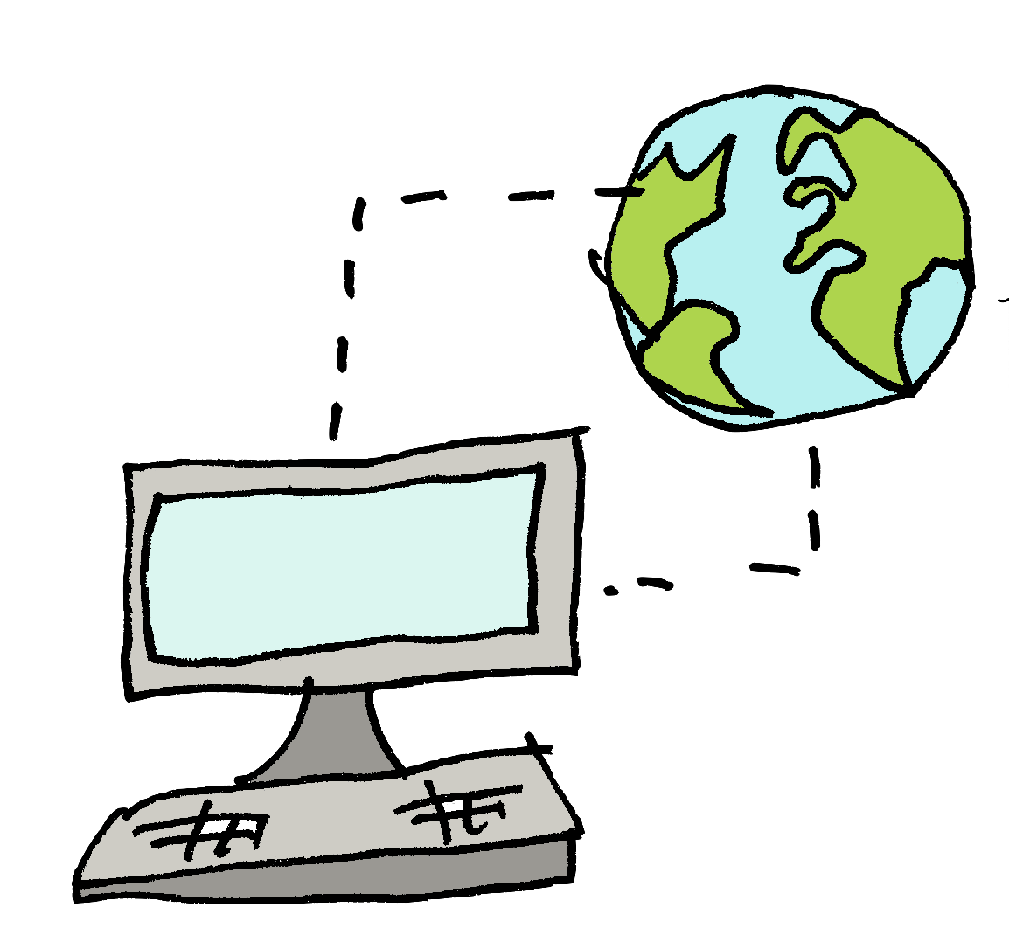

https://cutt.ly/QtvAkwq

Here, you can watch a mini-book being made and follow the instructions.

Or try this:
