Home Learning Plans
Lilac Class
Week Beginning: Monday 6th July
Reading:
- Carry on with your daily independent reading.
- If you want to enter the writing competition about your experience of Lockdown remember you need to submit your entry by Friday 17th July

- Our new whole class reading text is Shackleton’s Journey by William Grill. This is a true story about an expedition crossing Antarctica from one pole to the other. Read pages 25-36 of and answer the comprehension questions. I have also recorded me reading the pages to you so you can follow the text Learning Video: Reading pages 25-36 from Shackleton’s Journey. Re-read the text again and occasionally stop and ask your child what they think the meaning of a tricky word could be, looking at the context of the sentence. As with Street Child, most of the questions are open ended and there may be several answers to the questions. The purpose of the exercise is to develop reading comprehension skills and to discuss the text – that is why I have not given you an answer sheet.

If you have not so, please sign up for this year’s Summer Reading Challenge. It started on Friday 5th of June and runs throughout the summer holidays, finishing at the end of September. It is aimed at children aged 4 – 11 and is completely free! The challenge features games, quizzes and downloadable activities to incentivise and encourage children and their families to take part in reading related activities at home. Children can choose their own reading goals, create book reviews, play games and collect virtual rewards. Parents and guardians can register their children online at www.sillysquad.org.uk Please see attached information.

- Visit the Oxford Owl website. https://www.oxfordowl.co.uk/ Click on the My Class Login section
Use the following details to log in to the newly created Lilac Class section.
Username: lilac101
Password: pupil
Click on the ‘My Bookshelf’ section and select reading books that are right for you. Use the ‘Age Groups’ section to help narrow down the search.
- When completing guided or supported reading of an age appropriate text, focus on analytical questioning. Use the analytical section of this questioning tool to generate questions that challenge your child to analyse what has happened in the story.
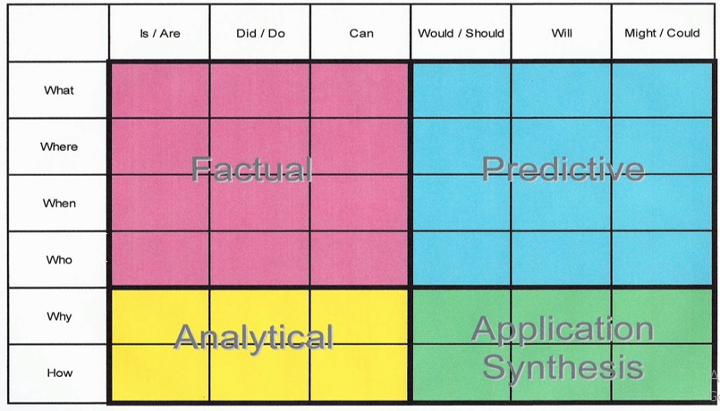
For example:
-Why did they do that?
-How can you tell that…?

Spelling, Punctuation and Grammar:
- On Purple Mash I have set the following ‘2Dos’: In the beginning – Linking ideas across paragraphs using a wider range of cohesive devices; Circus Tricks – use the colon to introduce a list and use commas or colons within lists.
- Work through the Classroom Secrets Varied Fluency with answers -Recognising the Future Perfect Form. We did not cover this in class before the Lockdown, so just have a go! Work through the easiest questions first with a grown up, looking at the answers.
Writing:
- LO: To draft a narrative focusing on character and setting. For this week I would like you to write a narrative (a story) called ‘Shipwrecked’. You are a sailor in 1720 and your life is hard. Describe how you became a sailor and the jobs you have to do onboard ship. What do you eat and drink? (a couple of weeks ago I asked you to research the life of a sailor in 1720 for your homework). There is a terrible storm and your ship is smashed up by the giant waves. Describe this experience. What did you feel, hear and see? Somehow, you managed to hold onto some wreckage and find yourself washed up on the beach of a tropical island. You are the only survivor and are shipwrecked on the island that is uninhabited. How do you survive on the island? Describe your life. How do you build your shelter and what do you eat? Are you able to grow any food? Do you find a river for water? How do you make your clothes? Do you get rescued by a passing ship? How does the crew know that you are on the island? Do you build a beacon out of dry vegetation and light it?

Maths: This week we are learning to multiply and divide decimals by 10, 100 and 1,000
Watch my learning video - LO: To multiply and divide decimals by 10, 100 and 1,000
- I have given you Classroom Secrets worksheets with answers about multiplying and dividing decimals by 10, 100 and 1000. This week I have put in both Varied Fluency and Reasoning and Problem Solving worksheets. Only do the Reasoning and Problem Solving worksheets if you feel confident.
- Complete your new Maths with Parents activity that is Rounding with 2 Decimal Places. Class code is 48372.

- Number Fluency and Revision: On Purple Mash I have set the following ‘2Dos’: Division with Remainders; Multiplying HTU X TU and Division Questions. I have set you a MyMaths Activity – Times Tables Booster: Mixed Tables.

- Wider Curriculum: Pick activities from the Wider Curriculum Learning Matrix. The new Wider Curriculum Learning Matrix contains activities for the rest of the term.

- I have will no longer attach my regular Homework sheet that your child would normally receive every Thursday as we have covered all the spelling patterns and words from the Year 5/6 Spelling List.

- PLEASE SEND ME ANY WORK YOU WOULD LIKE ME TO SEE OR YOU WOULD LIKE PUT ON OUR CLASS BLOG.

