Home Learning Plans
Beech Class
Week Beginning: Monday 8th June
Reading:
- The National Literacy Trust has created a selection of materials designed to support young readers at home.
https://literacytrust.org.uk/family-zone/5-8/young-readers-home/
Here are three of the activities that you might light to try this week:
-Aye Aye Captain
-Book Games For Story Time
-Story Street Names

- Visit the Oxford Owl website. https://www.oxfordowl.co.uk/ Click on the My Class Login section
Use the following details to log in to the newly created beech class section.
Username: beechclass101
Password: pupil
Click on the ‘My Bookshelf’ section and select reading books that are right for you. Use the ‘Age Groups’ section to help narrow down the search.

- When completing guided or supported reading of an age appropriate text, focus on factual questioning. Use the factual section of this questioning tool to generate questions that challenge your child to recall what has happened in the story.
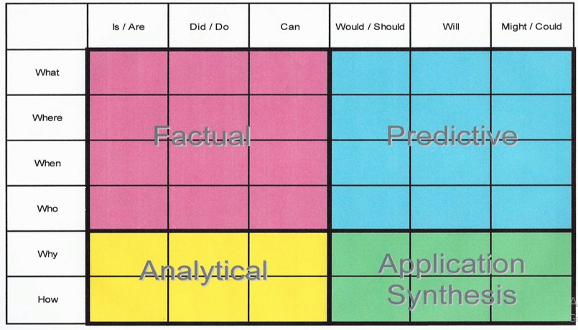
For example:
-When did the character go to the shops?
-What did they do next?
-Who is in the shop?
-Where are the characters going?

- JK Rowling is publishing chapters from her new children’s book ‘The Ickabob’ each day on the following website: https://theickabog.com/
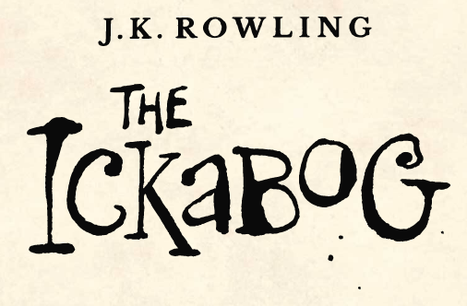
She is also asking children to send in their own illustrations that can be used in the book when it is published. Details for how to enter to illustration competition are on the website.

Spelling:
- Log on to Purple Mash and complete the spelling ‘2Dos’ which have been selected for you.

Writing/Topic/Science
This week we are going to learn all about habitats and then complete a Local Habitat Study.
- Watch the following videos. They provide information about different types of habitat:
-Polar Habitat
https://www.bbc.co.uk/bitesize/topics/zx882hv/articles/z3sr4wx
-Ocean Habitat
https://www.bbc.co.uk/bitesize/topics/zx882hv/articles/zsfkd2p
-Woodland Habitat
https://www.bbc.co.uk/bitesize/topics/zx882hv/articles/zc42xnb
-Rainforest Habitat
https://www.bbc.co.uk/bitesize/topics/zx882hv/articles/zxdsvcw
-Urban Habitat
https://www.bbc.co.uk/bitesize/topics/zx882hv/articles/zw2syrd
-Desert Habitat
https://www.bbc.co.uk/bitesize/topics/zx882hv/articles/zsqnfg8
-Coastal Habitat
https://www.bbc.co.uk/bitesize/topics/zx882hv/articles/zy38wmn
-Pond Habitat
https://www.bbc.co.uk/bitesize/topics/zx882hv/articles/ztf4kqt

- Explore the habitats surrounding Grosvenor and Hilbert Park. Can you find examples of the any of the habitats that you have just learned about?
- Pick a habitat from your locality. Use fieldwork skills to record information about this habitat.
-Make observations
-Take notes
-Complete sketches
-Record data
-Collect samples
If you want to find out more about what effective fieldwork looks like for primary aged children, the Royal Geographical Society has put together a guide to help:
https://www.rgs.org/schools/teaching-resources/developing-primary-geography/fieldwork/#
- Create a presentation which shows what you have learned about the habitat of your choice from the research and fieldwork you completed. You could create a digital, paper or verbal presentation. It is totally up to you! If possible, please send in anything that you create via the class email address.
- Use google maps to find satellite images of the area surrounding Grosvenor and Hilbert Park. Use these images, as well as your own knowledge gained from exploring the park, to create your own map of the park. Use a key to identify points of interest on the map- including the different habitats that you identified.

Maths:
This week we are going to continue to cement and extend our understanding of multiplication.
- Log on to Purplemash and complete the multiplication and division 2Dos that have been set for you:
-Arrays Division Statements
-Multiplication Expressions
-Relating + and x to objects
- If you have not done so already, watch the multiplication learning video.
- Revisit the two methods of multiplication that we looked at last week. If you have not done so already, complete the ‘Multiplication Efficient Method’ activity.
- Now I want you to extend your understanding of multiplication by completing some reasoning problems. Mr Mackinnon says:

“It doesn't matter which way around you put the factors in a multiplication calculation, the product is the same.”

Is this Always, Sometimes or Never true? Prove it!

- Revisit your understanding of odd and even numbers. If you need to spend some more time on this concept, watch the following videos:
https://www.bbc.co.uk/bitesize/topics/zknsgk7/articles/zt4jj6f
- Use your understanding of odd and even numbers, multiples of 2,5 and 10 and Venn Diagrams to complete the ‘Reasoning with Odd and Even Numbers’ activity.
- Here are some extra multiplication challenges from the nrich website:
-Doubling Fives: https://nrich.maths.org/10588
-Odd Times Even: https://nrich.maths.org/8062

Number Fluency:
- Log on to MyMaths and complete the following times tables activities:
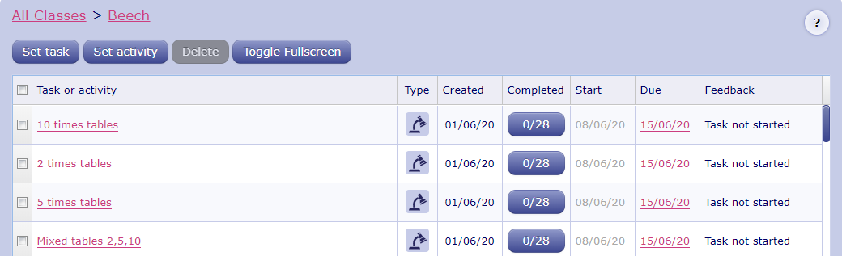
- If you haven’t done so already, Watch the ‘Multiplication and Division Fact Families’ learning video:
- Log on to Times Tables Rockstars and start practising your multiplication and division facts for the 1 2, 5 and 10 times tables. Use your learning from the ‘fact family’ activities to help you work out the division facts.
IMPORTANT: If you feel that your child has mastered these times tables and requires a new challenge, please contact us via the class email address: beech@st-barnabas.kent.sch.uk so we can allocate a new level of challenge for your child.

Wider Curriculum
- Pick activities of your choice from the wider curriculum matrix.

