Supported Independent Group
Wednesday 21st October 2018
L.O. To add and subtract multiples of 10
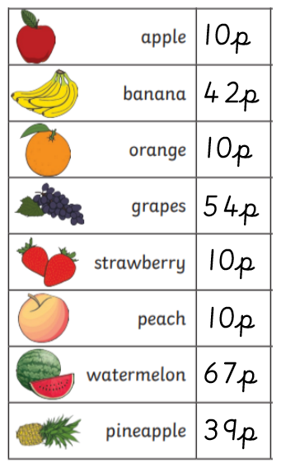

How much does a banana and 2 apples cost?

How much does grapes and 3 oranges cost?

How much does a watermelon and 1 peach cost?

How much does a pineapple and 2 strawberries cost?
How much does a banana and 3 oranges cost?

I have 47p in my wallet. I buy 2 peaches. How much do I have left?
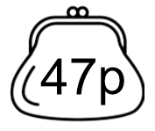

I have 64p in my hand. I buy 3 apples. How much do I have left?
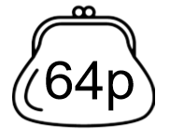

I have 89p in my purse. I buy 1 strawberry. How much do I have left?

I have 72p to spend. I buy 3 oranges. How much do I have left?
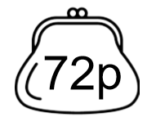

Mark buys a watermelon and 2 oranges.
Sarah buys grapes and 3 oranges.
Who spends the most money?

Tom buys a banana and 2 apples.
Ivy buys a pineapple and 2 peaches.
Who spends the most money?

Sue has 87p. She buys 3 strawberries.
Tim has 72p. He buys 1 apple.
Who has the most money left?

Ian has 49p. He buys 2 oranges.
Julie has 54p. She buys 2 apples.
Who has the most money left?

