01/03/21
I am learning to subtract with money
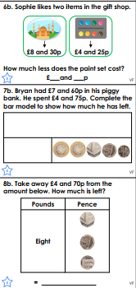
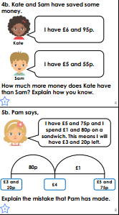
Answers
6b. £4 and 5p

7b. £2 and 85p

8b. £4 and 10p

4b. Kate has £1 and 40p more than Sam because
£6 and 95p
- £5 and 55p
= £1 and 40p

5b. Pam has calculated £5 and 75p - £1 incorrectly.
£5 and 75p
- £1
= £4 and 75p
Not £4
£5 and 75p
- £1 and 80p
= £3 and 95p

