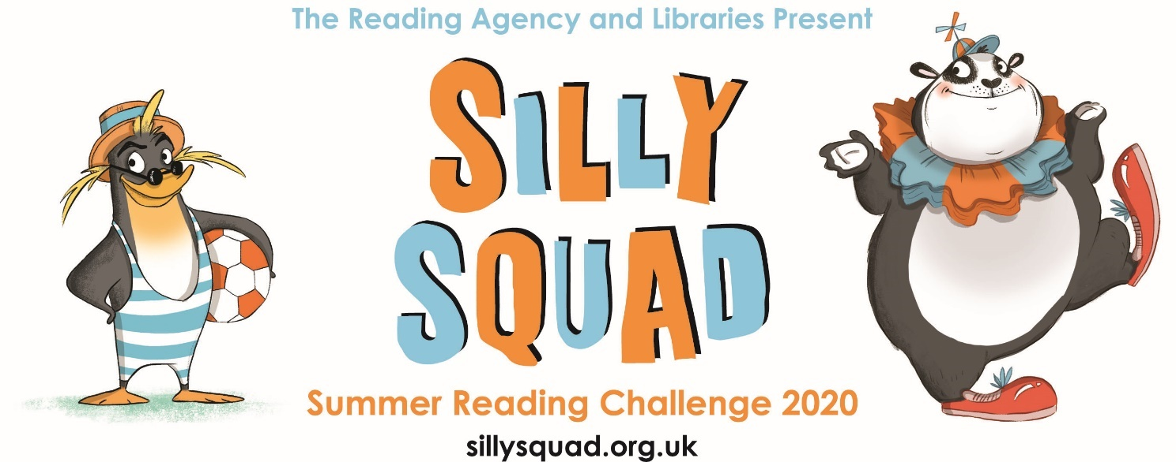

Illustrations © Laura Ellen Anderson 2020

The Summer Reading Challenge is back!

Silly Squad, Summer Reading Challenge 2020 starts on Friday 5 June and runs throughout the summer holidays, finishing at the end of September. It’s aimed at children aged 4 – 11 and is completely free! With COVID-19 disruption meaning that public libraries are currently closed and many children still being home schooled, for the first time in Kent, the Summer Reading Challenge is going to be a digital only activity to keep children reading and support parents / carers with children already at home.
This year’s theme is “Silly Squad” – focussing on funny books, happiness and things that make us laugh. Children taking part in the challenge join the Silly Squad, an adventurous team of animals who love to have a laugh and get stuck into many different kinds of funny books. It features bespoke artwork from award-winning children’s author and illustrator Laura Ellen Anderson (Amelia Fang; Evil Emperor Penguin; I Don’t Want Curly Hair).
Children's reading can dip during the long summer holidays if they do not have regular access to books and encouragement to read for pleasure, and the annual Summer Reading Challenge is intended to address this. Last year 19,111 Kent children took part, with 11,175 children completing the Challenge - significant increases of 12% and 15% respectively on 2018.
Usually children visit their local library to register and collect a wallet, stickers and other rewards as they progress through the challenge, reading a total of six books. This year’s Challenge is different – it’s a digital Challenge! It’s free to access, featuring games, quizzes and downloadable activities to incentivise and encourage children and their families to take part in reading related activities at home. Children can choose their own reading goals, create book reviews, play games and collect virtual rewards. Parents and guardians can register their children online at www.sillysquad.org.uk via the safe, sign-up process.
Although library buildings are closed, Kent Libraries will continue to deliver the Challenge by promoting it to families, and eBooks and eAudio books are free to borrow from www.kent.gov.uk/libraries with titles for children as well as adults – there is a special children’s catalogue on our Overdrive platform (click on the ‘explore’ option to find it). EBooks and eAudio books are automatically returned so you don’t need to keep an eye on the due date! If you need help with online catalogue, contact our Ask A Kent Librarian Team https://www.kent.gov.uk/leisure-and-community/libraries/free-computers-and-wifi/ask-a-kent-librarian
The Summer Reading Challenge has been a great success in previous years and an effective way to encourage children to continue regular reading while schools are closed for the holidays.
With school life disrupted and many children missing the company of their friends, this year’s Summer Reading Challenge will be even more vital as a way of helping parents and carers find fun, family-friendly activities, maintain literacy levels and create a safe space for children to connect with their peers.
Children’s author Jacqueline Wilson (Summer Reading Challenge Ambassador), said: “I feel the challenge is extra important this year! How sensible to have a Silly theme. We've all had to deal with serious and scary issues, so it's time for a bit of fun. There are so many comical and crazy children's books to cheer us all up. Let's get reading and get happy!”
The Summer Reading Challenge is produced by The Reading Agency in conjunction with libraries. Find out more about the Challenge at www.summerreadingchallenge.org.uk

Feedback from last year highlighted what a difference the challenge made to Kent children’s reading over the summer:

  - I personally think this activity is awesome because it makes sure I'm reading and it's so fun. Also I like it because it takes my mind off other things. This great challenge has made me more engrossed in my books. I've had a lovely time doing this. Girl Aged 9, Pembury

  - I'm going to borrow lots of books! I'm going to read all the books in the library on space. Boy, Sevenoaks

Greetings Earthlings Space Poems’: [my son] loved this book. He was rapping the poems and really enjoyed doing so. He has now choses 'Laugh out loud' poems. What a great way to start appreciating poetry. Parent of boy aged 8, New Ash Green

This challenge is really good for the boys. He even read to his younger brother this morning to help him finish his second book. Parent of boys aged 5 & 9, Swanley

As a teacher and a parent, I love the reading challenge. It keeps those skills and the joy of books going on the long summer break, without making reading sound like hard work. Parent, Deal

The Summer Reading challenge has really helped keep up with school reading. One week back at school and my son moved up a reading band! Parent of boy aged 6, Swalecliffe

Contact Details

Karen Sillifant
Tel: 03000 414439
karen.sillifant@kent.gov.uk

