Positives for House Building | Material/Key Properties | Negatives for House Building
Wood
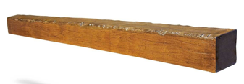
strong, rigid, quite flammable, opaque
Straw
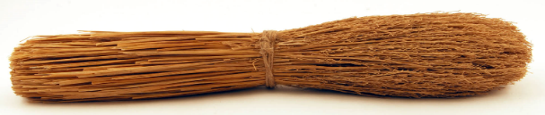
fragile, flexible, very flammable, opaque
Pitch
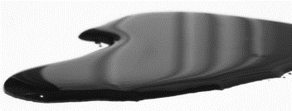
flexible, waterproof, extremely flammable, opaque
Glass
fragile, rigid, transparent

