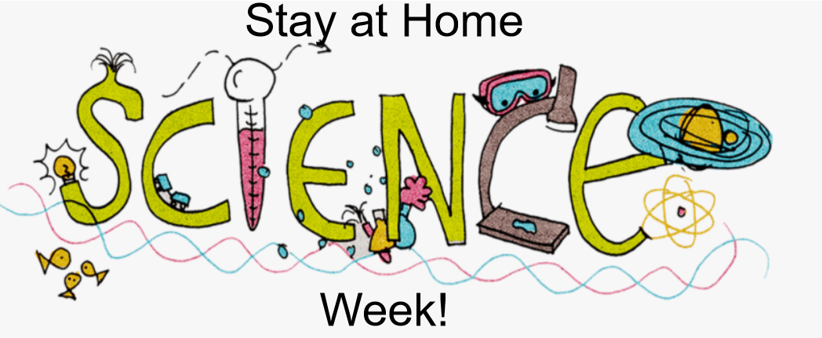

How Do I Take Part?
Step 1- Find the plans and resources on the school website. (You have already done this!)
Step 2: Select an activity from the list below.
Step 3- Follow the link, watch the video, and/or read the instructions.
Step 4- Complete the scientific activity with the support and guidance of an adult.
Step 5- Record how many ‘Science Week Electrons’ you have earned.

2 Electron Activities:
Each time you complete one of these activities, you can add 2 ‘Science Week Electrons’ to your total. Instructions for each activity can be found using the following link or in the documents attached to the bottom of this page.
https://www.stem.org.uk/resources/elibrary/resource/25416/do-try-home#&gid=undefined&pid=2
- The Forceful Comb

- Alka-Seltzer Rocket

- Magic Balloon

- Make a Lava Lamp

3 Electron Activities:
Each time you complete one of these activities, you can add 3 ‘Science Week Electrons’ to your total. A video and instructions for each activity can be found by following the relevant links. Instructions for each activity are attached to the bottom of this page.
- Giant Bubbles
https://www.rigb.org/families/experimental/giant-bubbles

- Playdough
https://www.rigb.org/families/experimental/playing-with-play-dough

- Musical Coat Hangers
https://www.rigb.org/families/experimental/musical-coat-hangers

- Singing Wine Glasses
https://www.rigb.org/families/experimental/singing-wine-glasses

4 Electron Activities:
Each time you complete one of the BIG QUESTIONS, you can add 4 ‘Science Week Electrons’ to your total.
- BIG Question (A) – The three little pigs built their houses from different materials. Build three houses for the pigs to live in out of different materials. Which one is stronger? How will you test this?

- BIG Question (B) – Is it dark when you go to bed at the moment? Was it dark when you went to bed at Christmas? Why has it changed?

- BIG Question (C) – Find 3 different types of paper around your house. Which one absorbs the most water? How will you test this?

5 Electron Activities:
Watch the video of Mr M modelling how to complete a ‘Fair Test’.
If you can complete your own fair test, you can add 5 ‘Science Week Electrons’ to your total. Here are some possible questions to investigate:
- Does the angle of the ramp affect how far the car travels?

- Does the type of car affect how far travels?

- Does the road surface affect how far the car travels?

- Does the starting position of the car affect how far it travels?

How do I get my certificate?
Don’t forget to count up how many ‘Science Week Electrons’ you have earned in total. Send this information to Mr Mackinnon: beech@st-barnabas.kent.sch.uk and we will organise your Stay at Home Science Week Certificate.
The closing date for entries is Tuesday 2nd June.

EXTRA CHALLENGE:
How do you think Mr M is going to use the number of electrons you have earned to work out which certificate you get? Can you predict which certificate you will receive before it even arrives.
CLUE: Mr Mackinnon is going to use a tool called the Periodic Table to help him.

