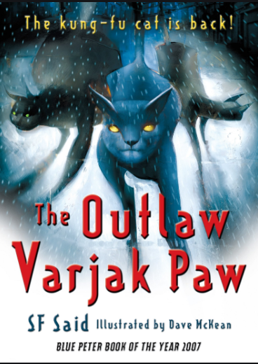
THIS WEEK WE ARE STARTING OUR NEW BOOK! So exciting. Now that you have all been given a copy by school, I will expect you to use that to answer your comprehension questions. We are starting with chapters 1 and 2 this week and I will provide page references where relevant.

QUESTIONS
P7 What do the words ‘harsh’ and ‘scarce’ mean? Find out and then write your own sentences using them correctly.

P8 Which phrases tell you that Holly and Tam are nervous?

P9 Why does the author use italics for ‘she’ ? Read it aloud to yourself to help you answer.

P9 Why are the words ‘thud, thud, thud’ set out in this way?

P11 How many skills are there?
P12 Who do you think the voice is behind Varjak Paw?

P13 What do the words ‘brawny’ and ‘bristling’ mean? Write your own sentences using them correctly.

P15 What do the words ‘crackled and fizzed’ add to the atmosphere?

P15 Can you remember what was unusual about Razor’s eyes?

P20 ‘Varjak’s stomach turned to liquid’ – what does this phrase mean?

P20 What might Cludge be thinking and feeling at the end of this page?

P21 ‘Big. Brawny. Barging’ – what technique has the author used here? Why?

SUMMARISE these 2 chapters in a maximum of 4 sentences – this will show how well you understand the narrative.

PREDICT what might happen next.

